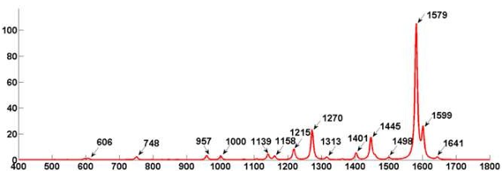

Figure 1: https://doi.org/10.33S0/s18041082

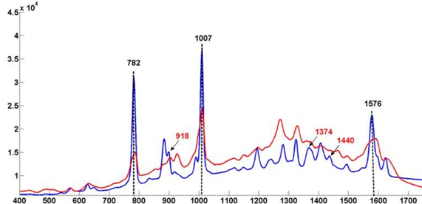

Figure 2: https://doi.org/10.33S0/s18041082

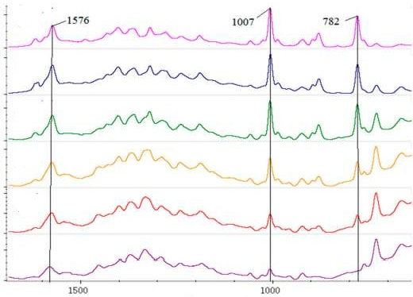

Figure 3: https://doi.org/10.33S0/s18041082

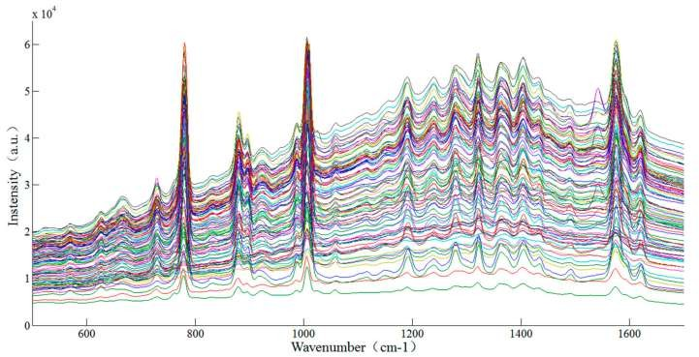

Figure 4: https://doi.org/10.33S0/s18041082

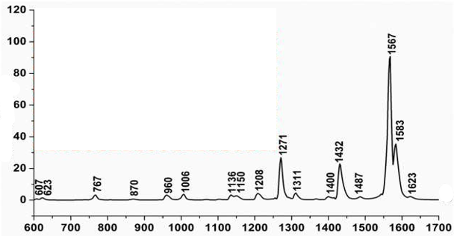

Figure 5: https://doi.org/10.33S0/molecules23081S4S

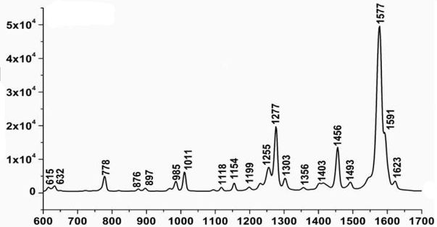

Figure 6: https://doi.org/10.33S0/molecules23081S4S

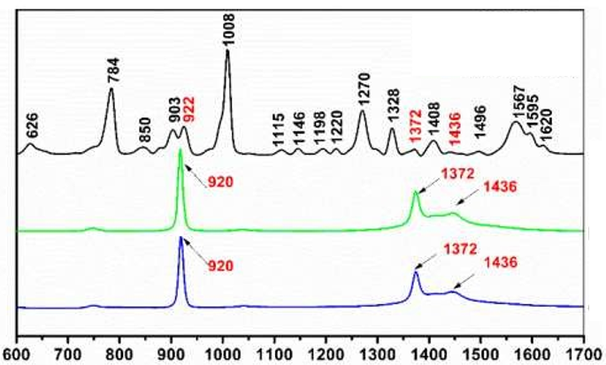

Figure 7: https://doi.org/10.33S0/molecules23081S4S

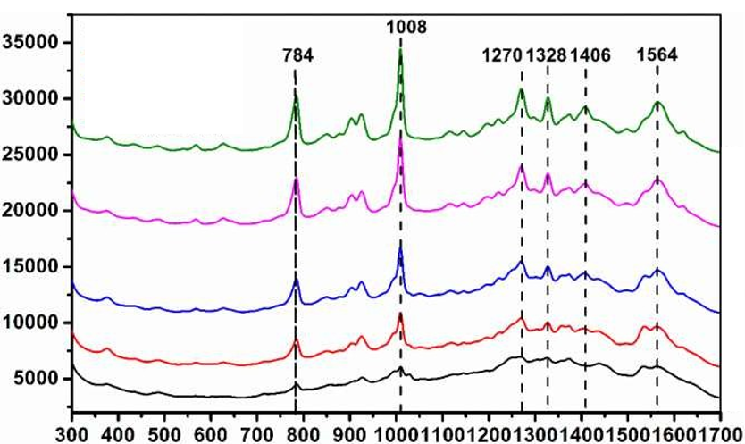

Figure 8: https://doi.org/10.33S0/molecules23081S4S

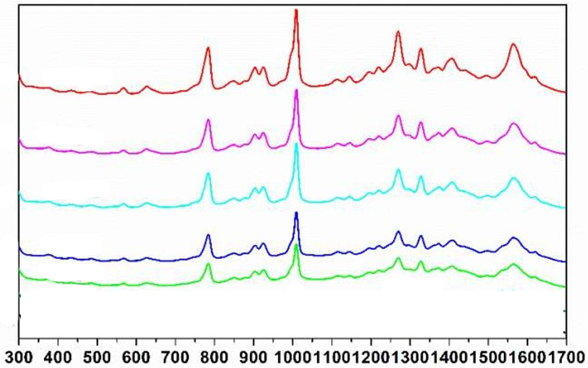

Figure 9:https://doi.org/10.33S0/molecules23081S4S

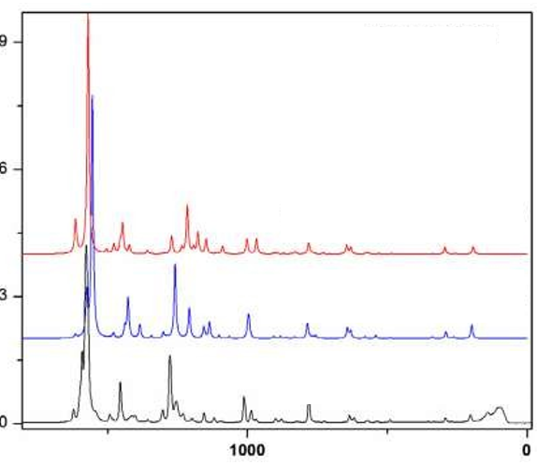

Figure 10:https://doi.org/10.101c/j.foodchem.2013.08.13c

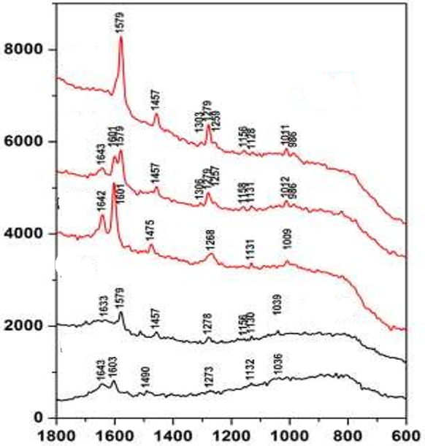

Figure 11:https://doi.org/10.101c/j.foodchem.2013.08.13c

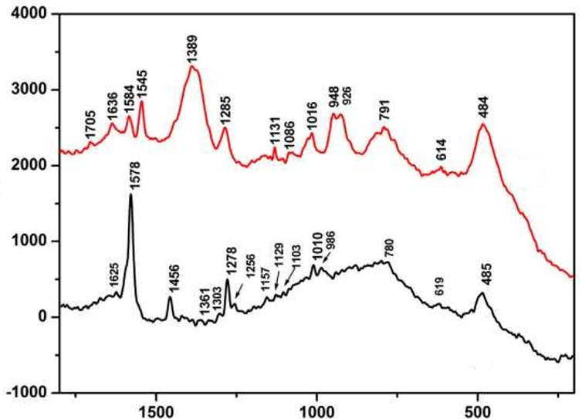

Figure 12:https://doi.org/10.101c/j.foodchem.2013.08.13c

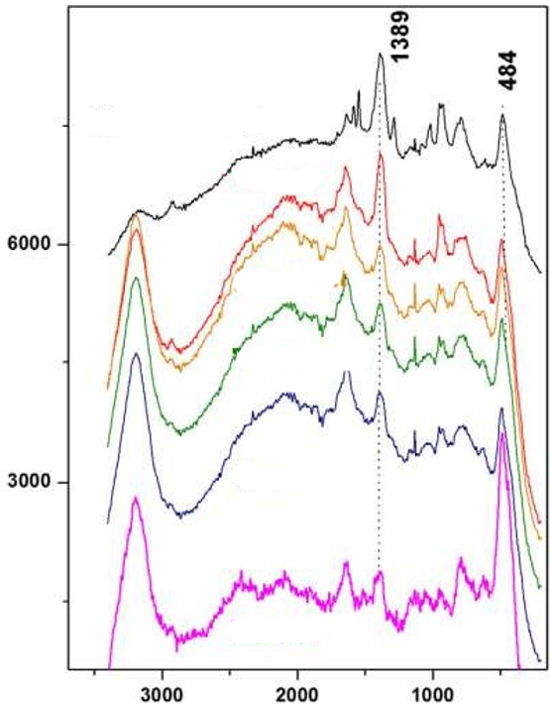

Figure 13:https://doi.org/10.101c/j.foodchem.2013.08.13c

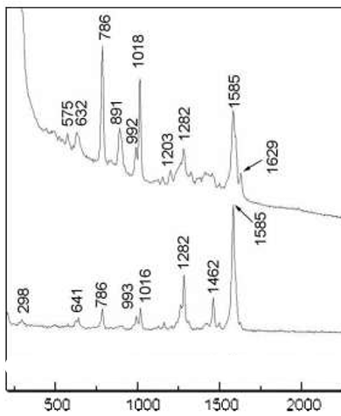

Figure 14:https://doi.org/10.5012/bkcs.200S.30.12.2S30

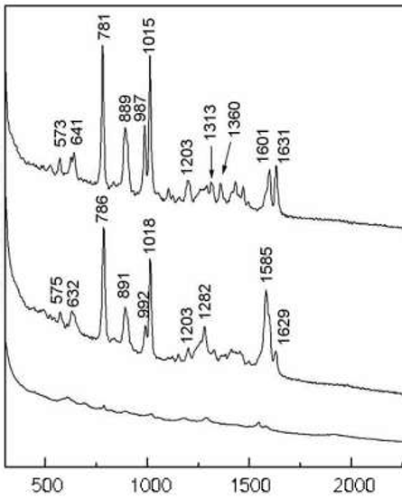

Figure 15:https://doi.org/10.5012/bkcs.200S.30.12.2S30

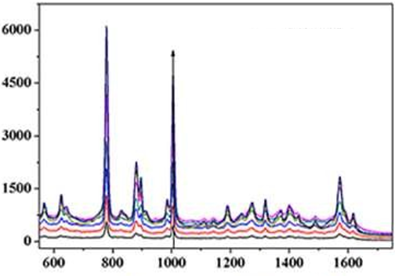

Figure 16:https://doi.org/10.101c/j.foodchem.2020.127843

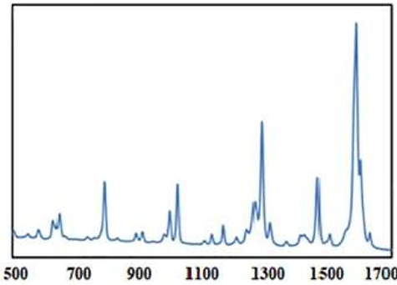

Figure 17:https://doi.org/10.101c/j.foodchem.2020.127843

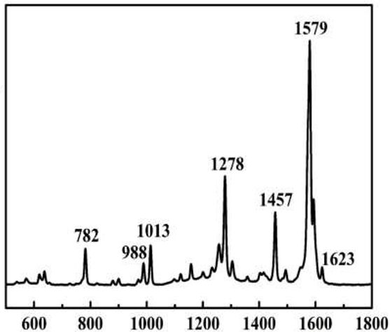

Figure 18:https://doi.org/10.101c/j.saa.2023.12318S

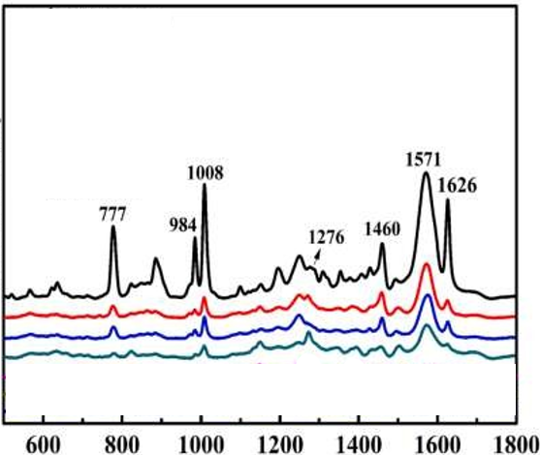

Figure 19:https://doi.org/10.101c/j.saa.2023.12318S

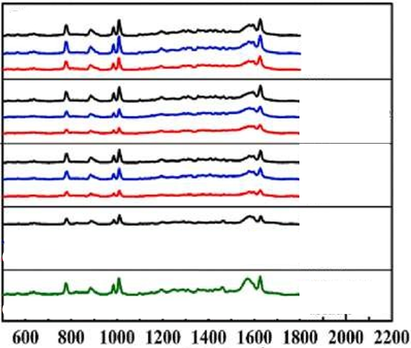

Figure 20:https://doi.org/10.101c/j.saa.2023.12318S

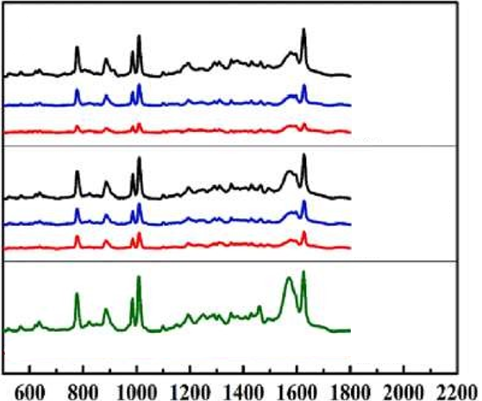

Figure 21:https://doi.org/10.101c/j.saa.2023.12318S

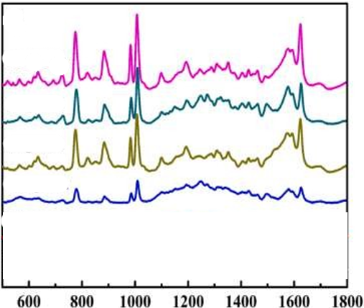

Figure 22:https://doi.org/10.101c/j.saa.2023.12318S

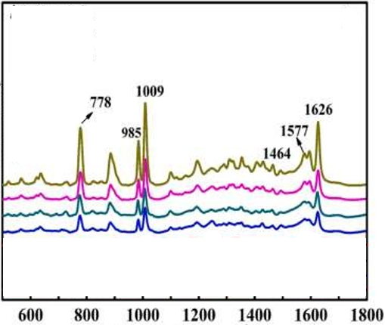

Figure 23:https://doi.org/10.101c/j.saa.2023.12318S

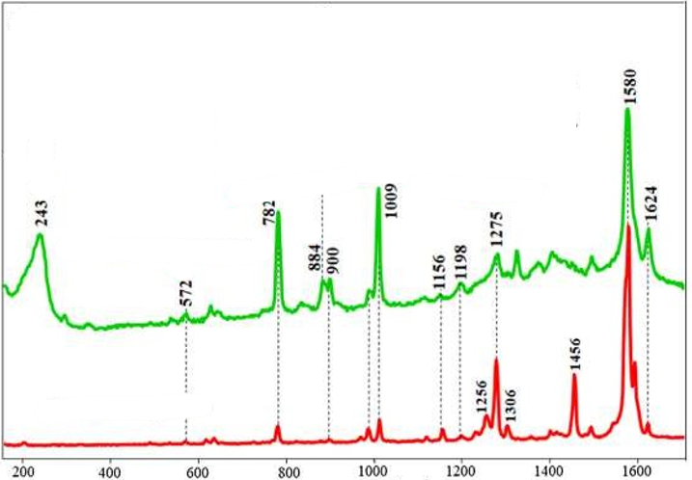

Figure 24:https://doi.org/10.101c/j.apsusc.2020.14578c

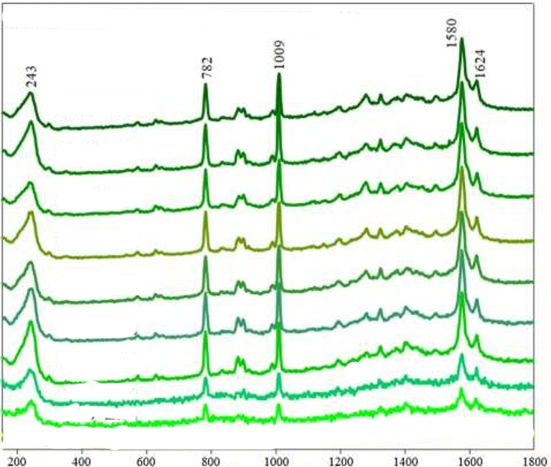

Figure 25:https://doi.org/10.101c/j.apsusc.2020.14578c

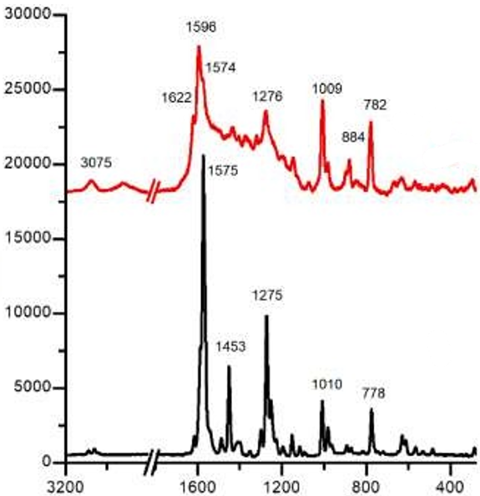

Figure 26:https://doi.org/10.101c/j.talo.2023.100223

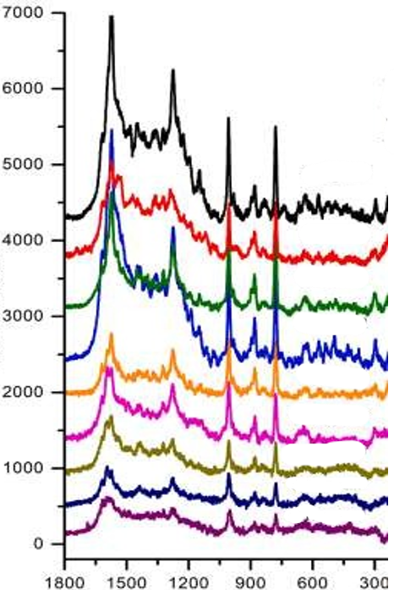

Figure 27:https://doi.org/10.101c/j.talo.2023.100223

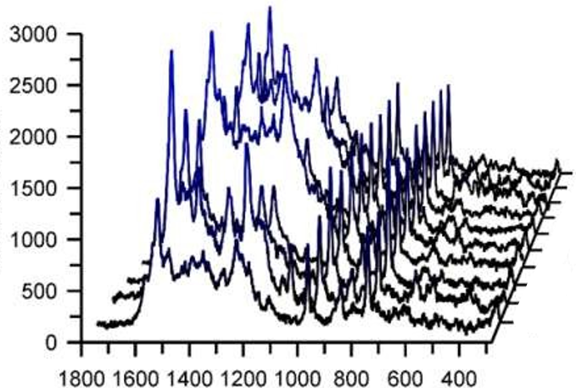

Figure 28:https://doi.org/10.101c/j.talo.2023.100223

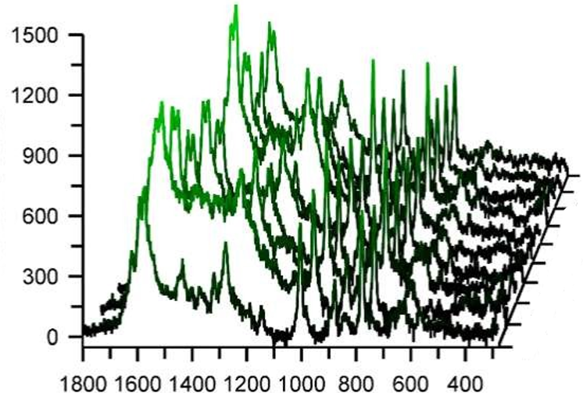

Figure 29:https://doi.org/10.101c/j.talo.2023.100223

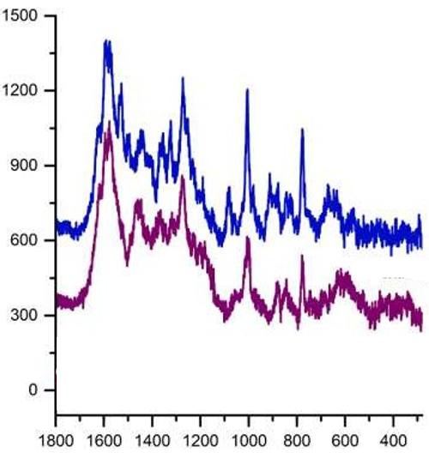

Figure 30:https://doi.org/10.101c/j.talo.2023.100223

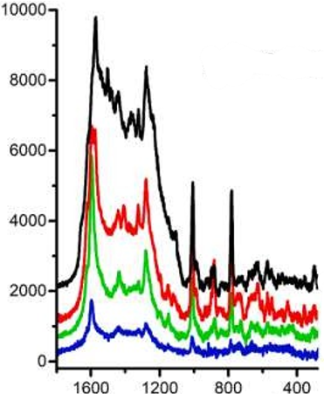

Figure 31:https://doi.org/10.101c/j.talo.2023.100223

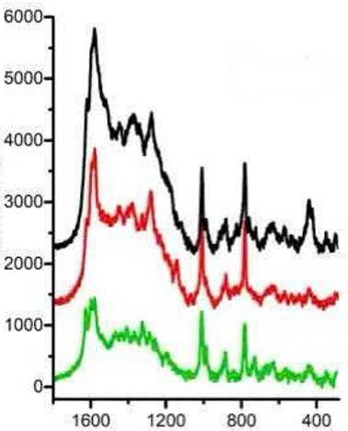

Figure 32:https://doi.org/10.101c/j.talo.2023.100223

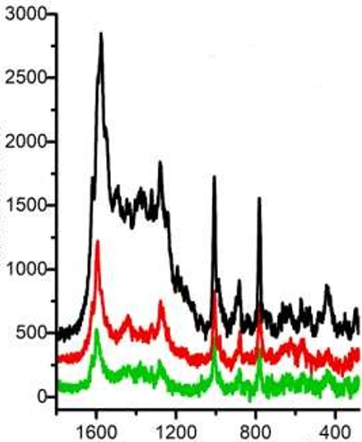

Figure 33:https://doi.org/10.101c/j.talo.2023.100223

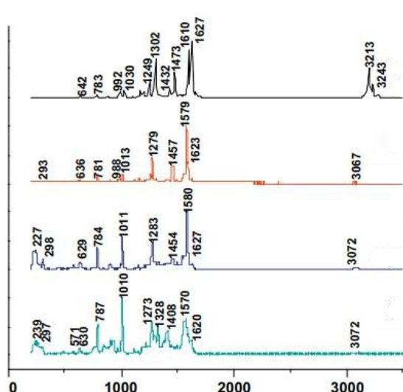

Figure 34:https://doi.org/10.101c/j.molstruc.2013.0c.0c0

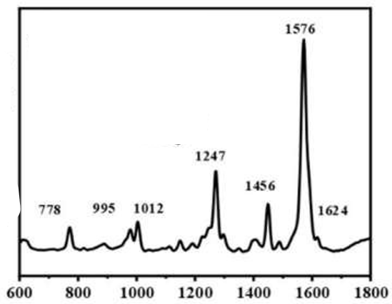

Figure 35:https://doi.org/10.1007/s0021c-023-05055-1

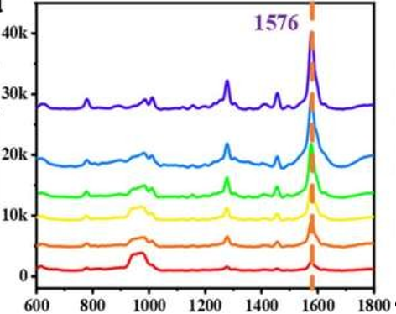

Figure 36:https://doi.org/10.1007/s0021c-023-05055-1

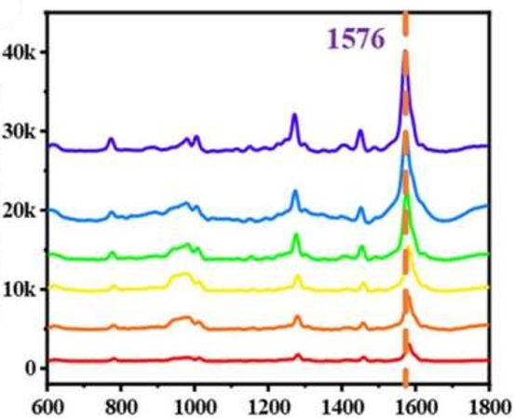

Figure 37:https://doi.org/10.1007/s0021c-023-05055-1

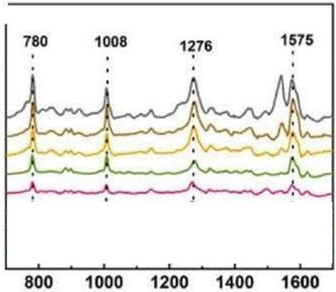

Figure 38:https://doi.org/10.101c/j.optmat.2025.1171c4

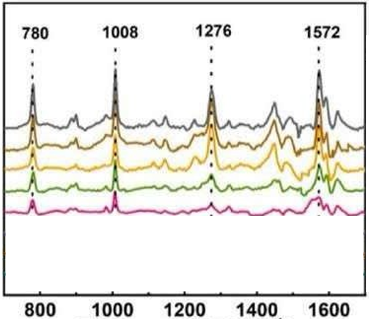

Figure 39:https://doi.org/10.101c/j.optmat.2025.1171c4

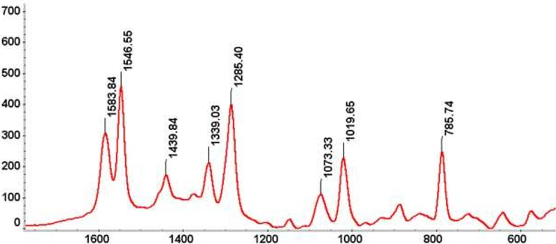

Figure 40:https://doi.org/10.101c/j.foodchem.2013.10.023

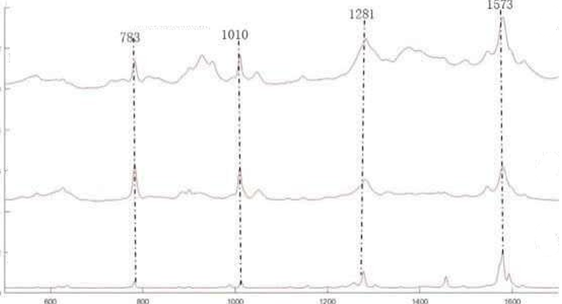

Figure 41:https://doi.org/10.101c/j.foodchem.2017.07.014

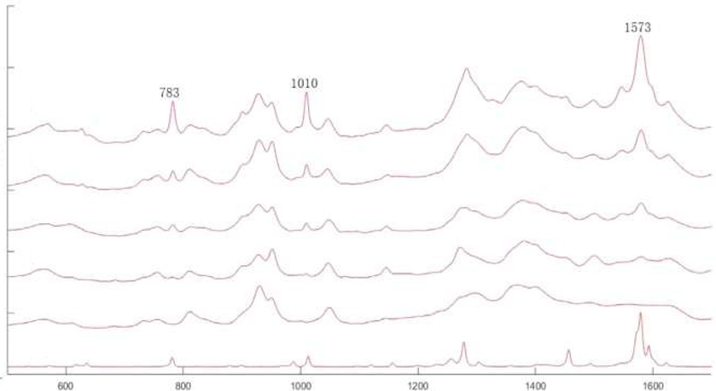

Figure 42:https://doi.org/10.101c/j.foodchem.2017.07.014

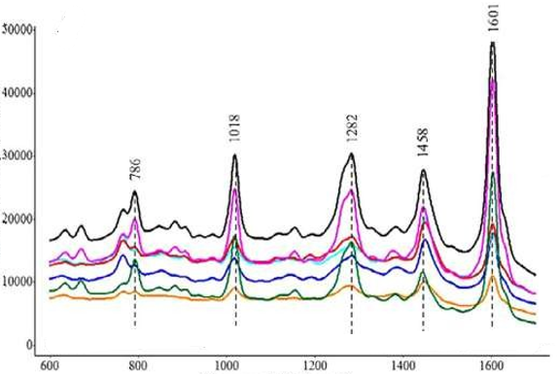

Figure 43:https://doi.org/10.101c/j.foodchem.2018.03.105

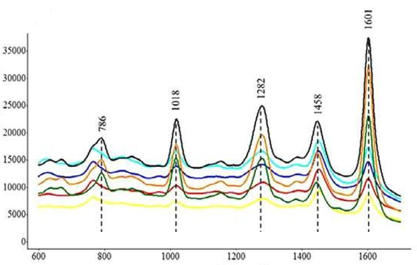

Figure 44:https://doi.org/10.101c/j.foodchem.2018.03.105



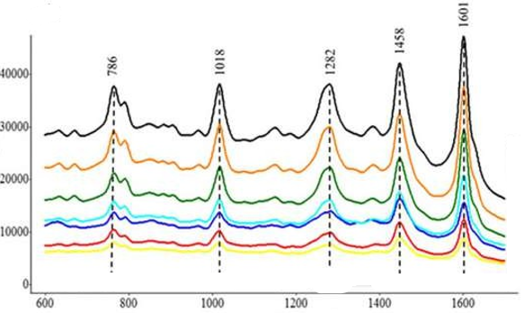

Figure 45:https://doi.org/10.101c/j.foodchem.2018.03.105

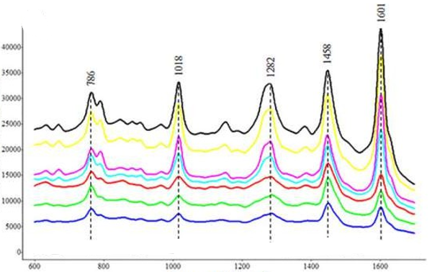

Figure 46:https://doi.org/10.101c/j.foodchem.2018.03.105

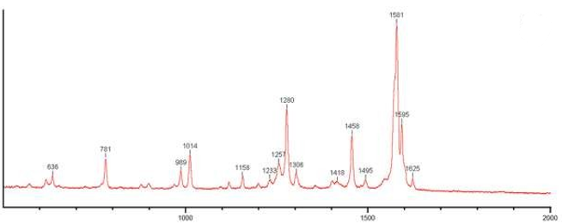

Figure 47:https://doi.org/10.101c/j.vibspec.2023.103544

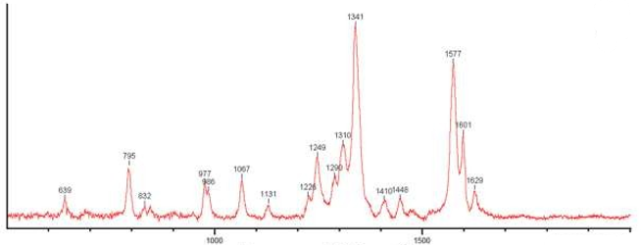

Figure 48:https://doi.org/10.101c/j.vibspec.2023.103544

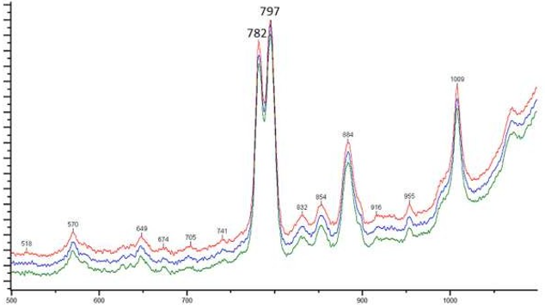

Figure 49:https://doi.org/10.101c/j.vibspec.2023.103544

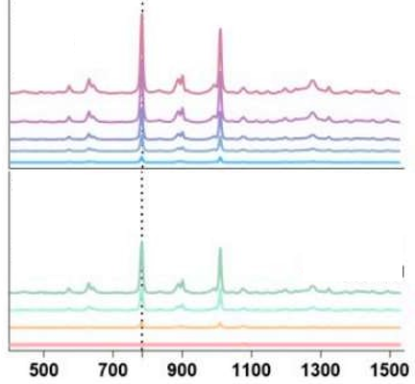

Figure 50:https://doi.org/10.33S0/bios14030133

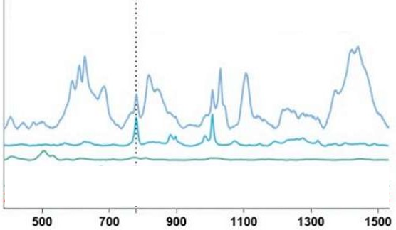

Figure 51:https://doi.org/10.33S0/bios14030133

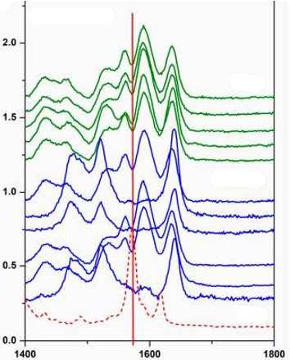

Figure 52:https://doi.org/10.33S0/chemosensors110S0505

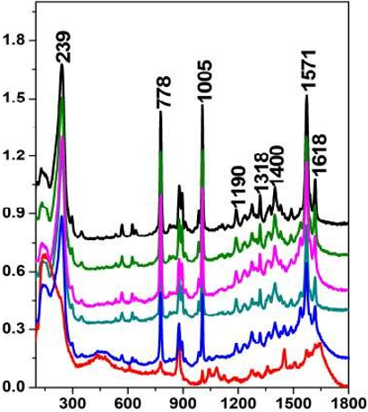

Figure 53:https://doi.org/10.33S0/chemosensors110S0505

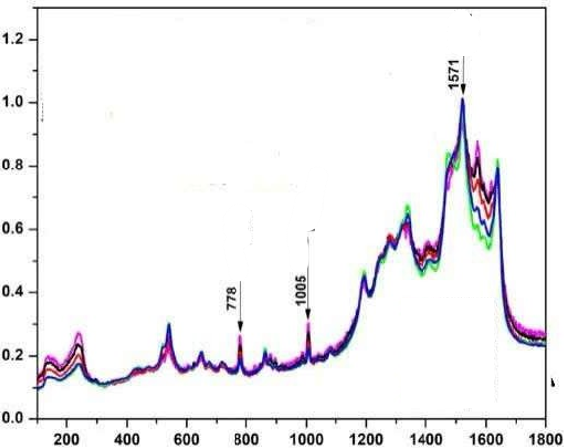

Figure 54:https://doi.org/10.33S0/chemosensors110S0505

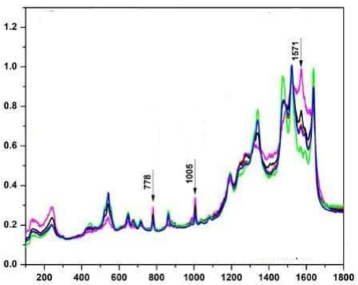

Figure 55:https://doi.org/10.33S0/chemosensors110S0505

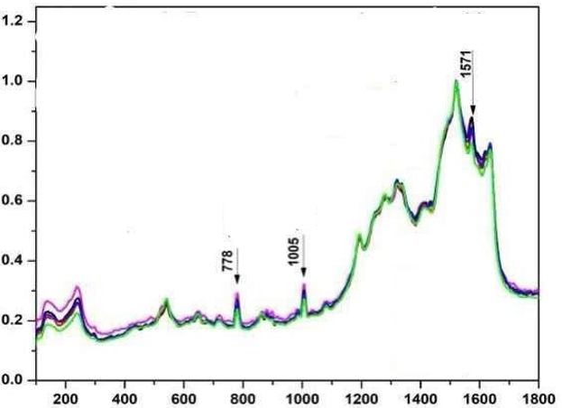

Figure 56:https://doi.org/10.33S0/chemosensors110S0505

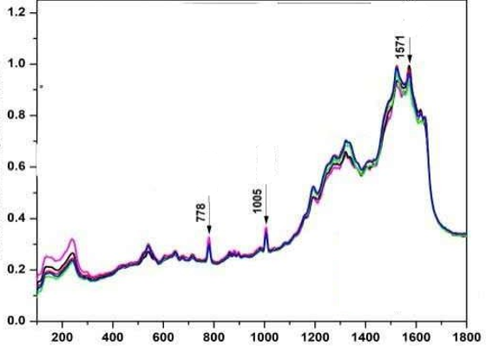

Figure 57:https://doi.org/10.33S0/chemosensors110S0505

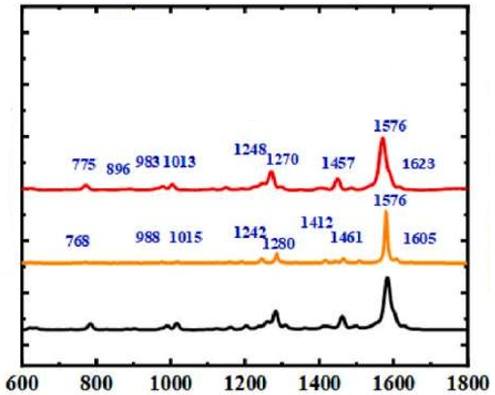

Figure 58:https://doi.org/10.101c/j.lwt.2023.115310

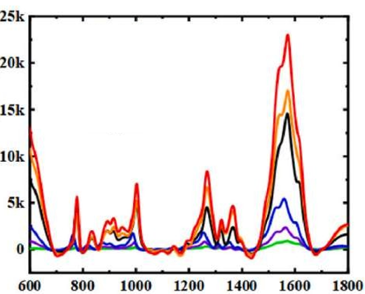

Figure 59:https://doi.org/10.101c/j.lwt.2023.115310

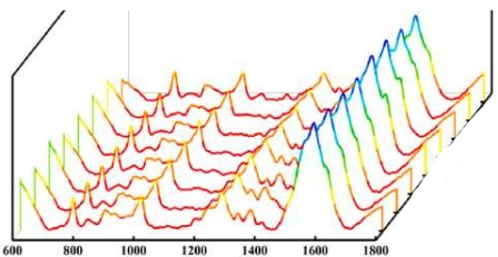

Figure 60:https://doi.org/10.101c/j.lwt.2023.115310

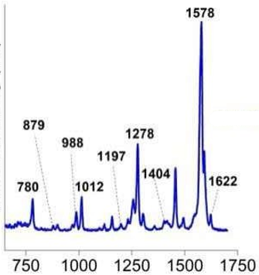

Figure 61:https://doi.org/10.101c/j.saa.2020.118S08

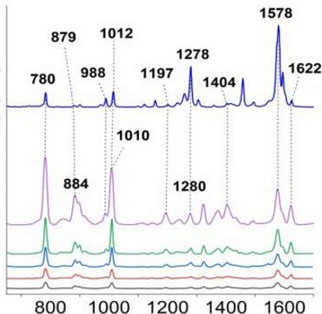

Figure 62:https://doi.org/10.101c/j.saa.2020.118S08

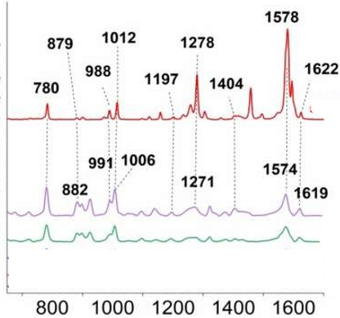

Figure 63:https://doi.org/10.101c/j.saa.2020.118S08

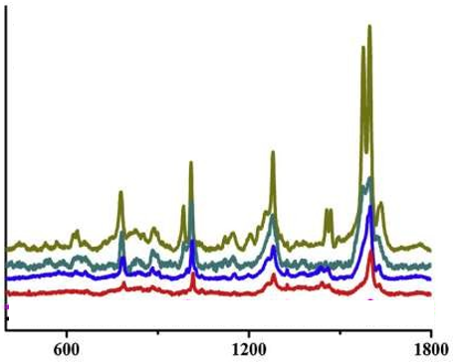

Figure 64:https://doi.org/10.101c/j.snb.201S.05.017

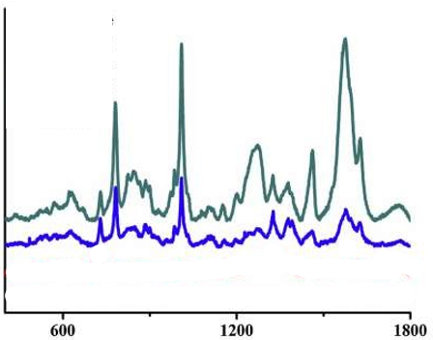

Figure 65:https://doi.org/10.101c/j.snb.201S.05.017

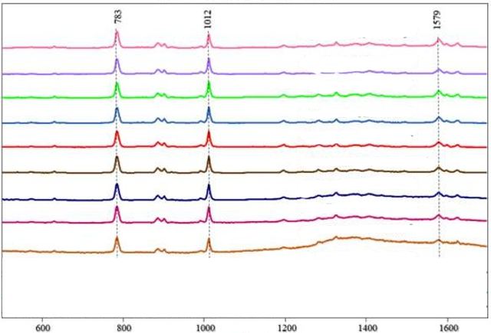

Figure 66:https://doi.org/10.1021/acsomega.4c0758c

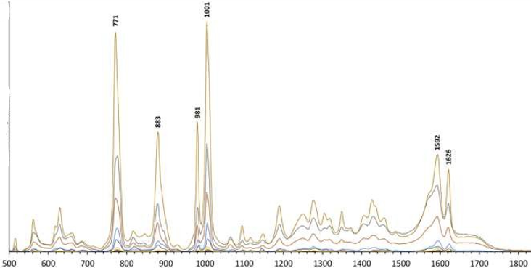

Figure 67:https://doi.org/10.101c/j.foodchem.2023.137703

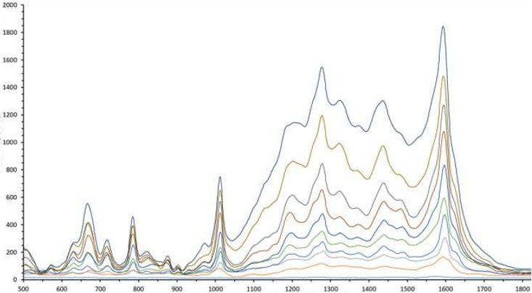

Figure 68:https://doi.org/10.101c/j.foodchem.2023.137703

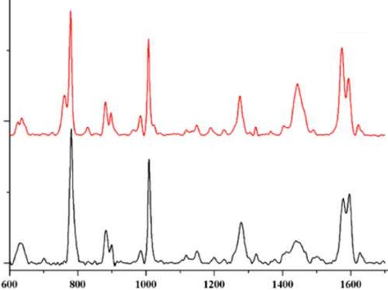

Figure 69: https://doi.org/10.101c/j.talanta.2018.11.114

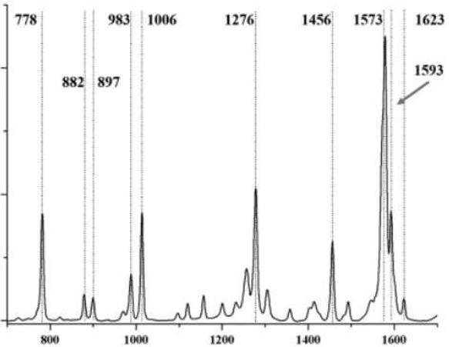

Figure 70: https://doi.org/10.101c/j.talanta.2018.11.114

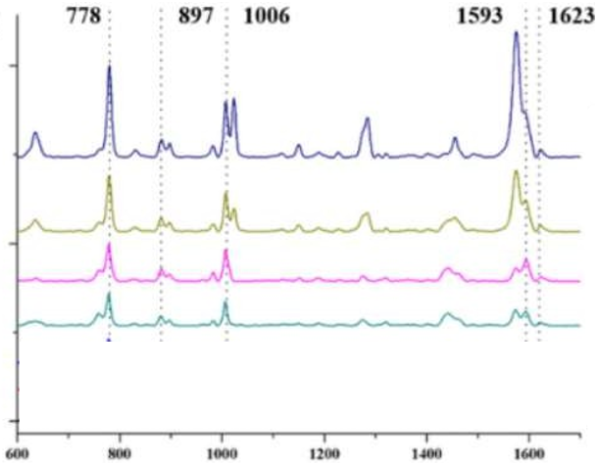

Figure 71: https://doi.org/10.101c/j.talanta.2018.11.114

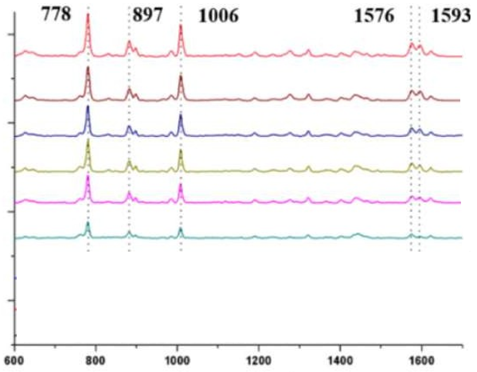

Figure 72: https://doi.org/10.101c/j.talanta.2018.11.114

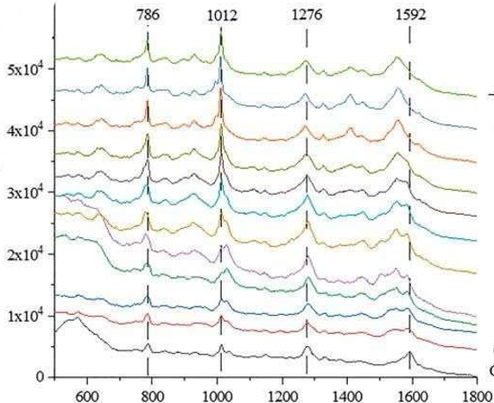

Figure 73: https://doi.org/10.101c/j.foodchem.2022.134713

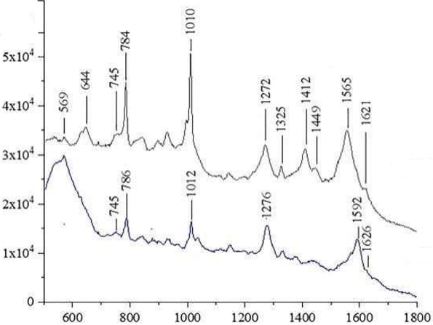

Figure 74:https://doi.org/10.101c/j.foodchem.2022.134713

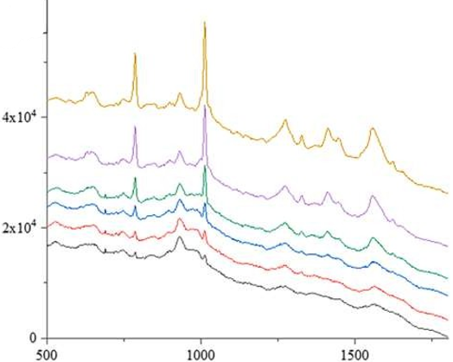

Figure 75:https://doi.org/10.101c/j.foodchem.2022.134713

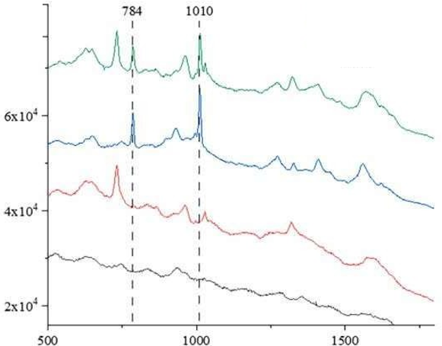

Figure 76:https://doi.org/10.101c/j.foodchem.2022.134713

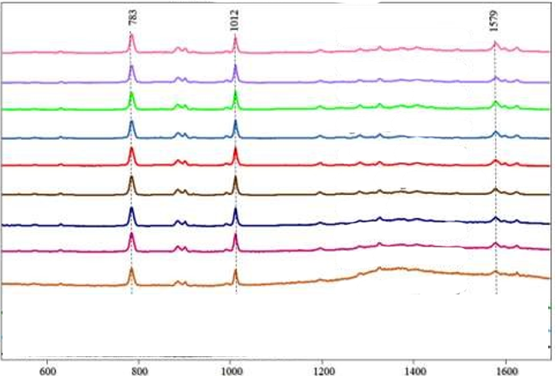

Figure 77:https://doi.org/10.1021/acsomega.4c0758c

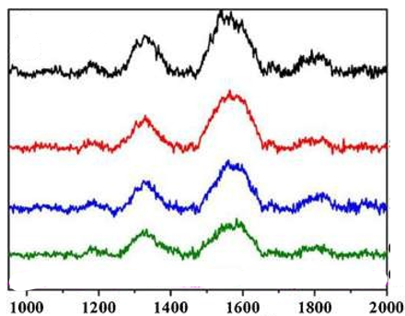

Figure 78:https://doi.org/10.1007/s00c04-01S-3543-1

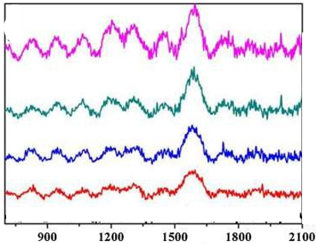

Figure 79:https://doi.org/10.1007/s00c04-01S-3543-1

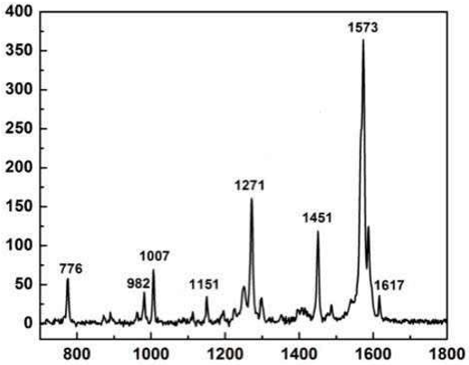

Figure 80:https://doi.org/10.101c/j.cplett.2023.1407c0

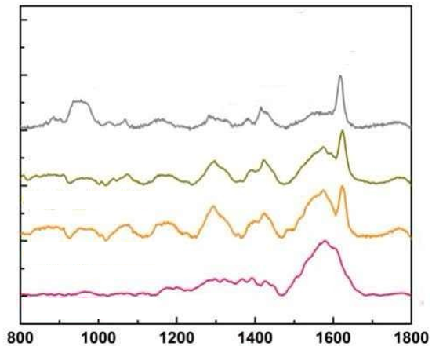

Figure 81:https://doi.org/10.101c/j.cplett.2023.1407c0

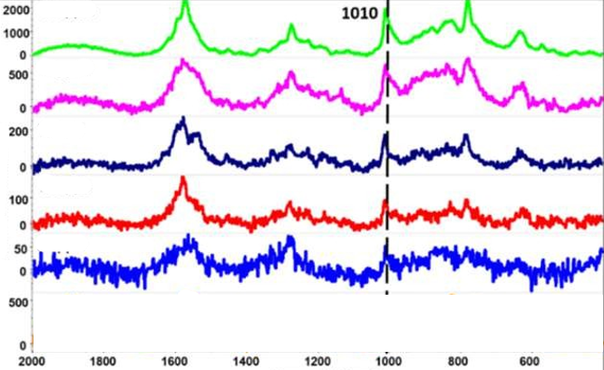

Figure 82:https://doi.org/10.1021/acs.analchem.8b04522

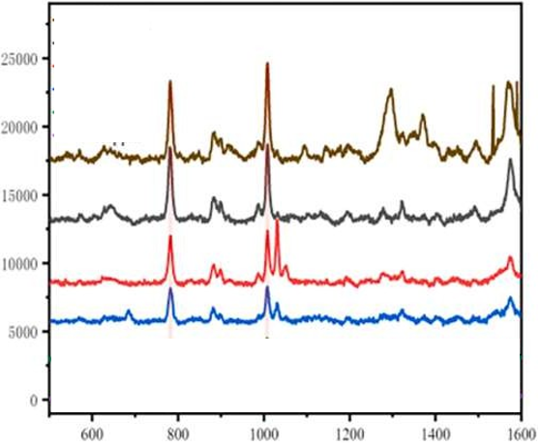

Figure 83:https://doi.org/10.101c/j.microc.2023.10S72S

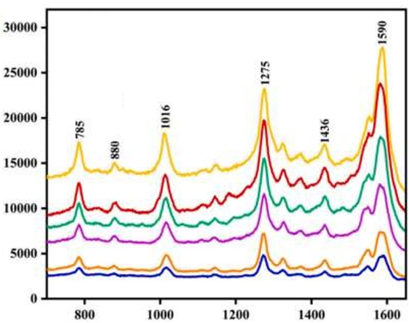

Figure 84:https://doi.org/10.101c/j.scitotenv.2024.175301

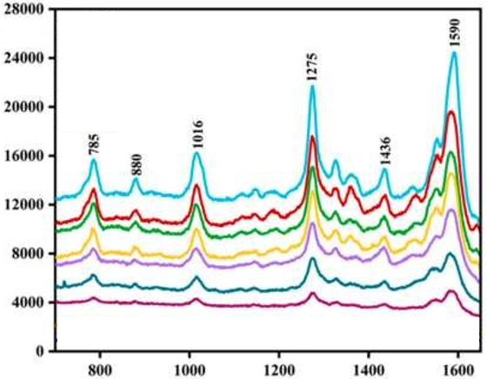

Figure 85:https://doi.org/10.101c/j.scitotenv.2024.175301

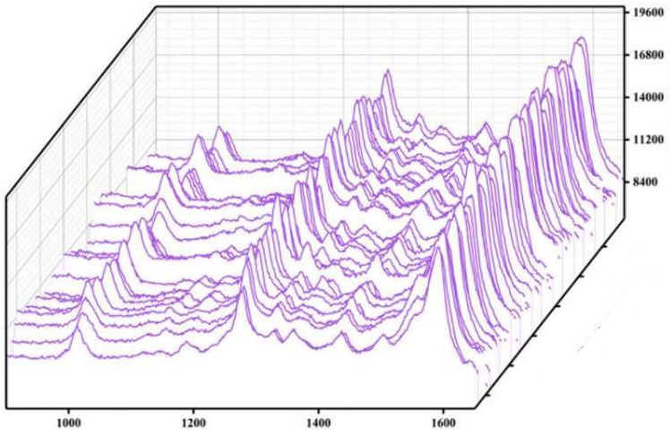

Figure 86:https://doi.org/10.101c/j.scitotenv.2024.175301

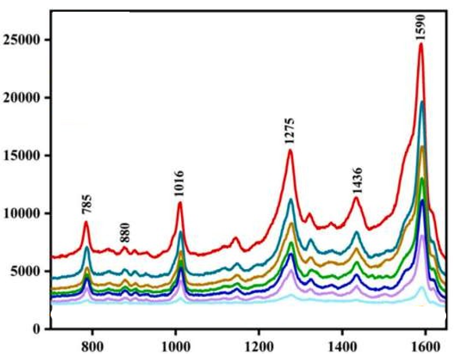

Figure 87:https://doi.org/10.101c/j.scitotenv.2024.175301

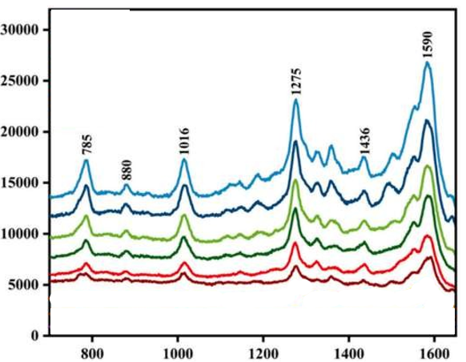

Figure 88:https://doi.org/10.101c/j.scitotenv.2024.175301

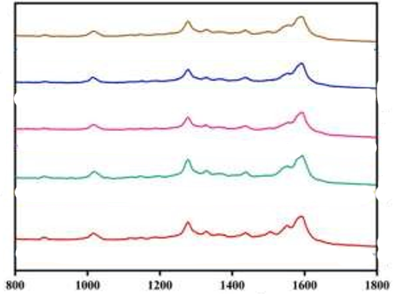

Figure 89:https://doi.org/10.101c/j.scitotenv.2024.175301

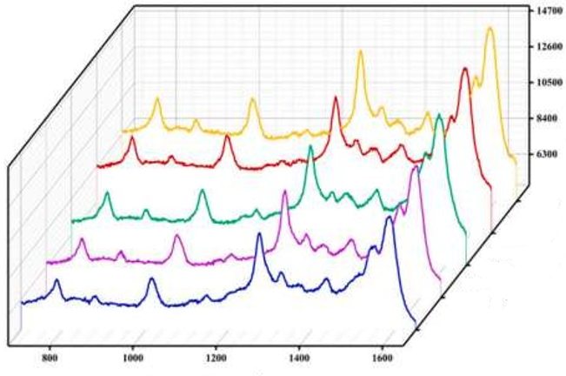

Figure 90:https://doi.org/10.101c/j.scitotenv.2024.175301

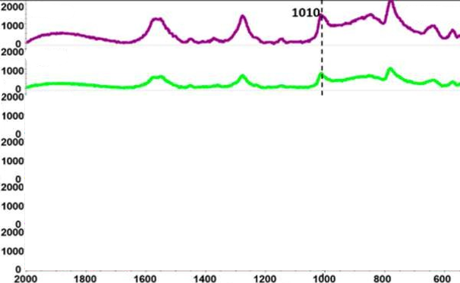

Figure 91:https://doi.org/10.1021/acs.jafc.7b00548

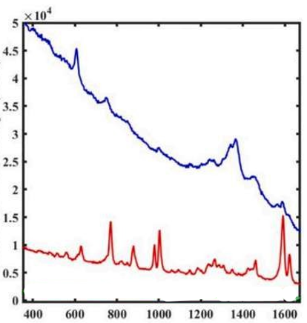

Figure 92:https://doi.org/10.101c/j.foodchem.2021.131c81

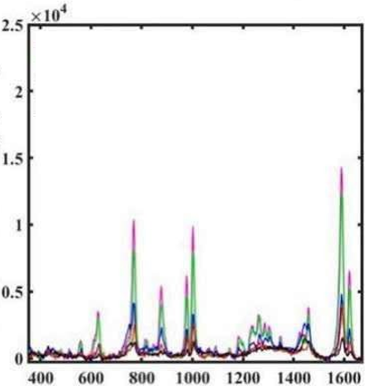

Figure 93:https://doi.org/10.101c/j.foodchem.2021.131c81

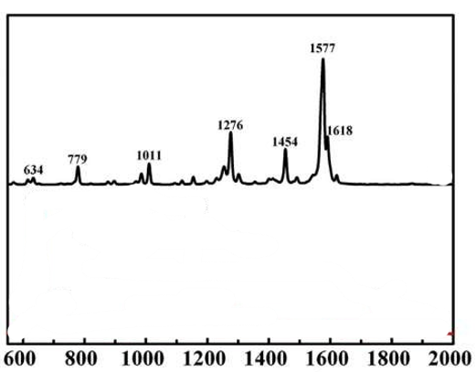

Figure 94: [https://doi.org/10.101c/j.foodcont.201c.04.003](https://doi.org/10.1016/j.foodcont.2016.04.003)

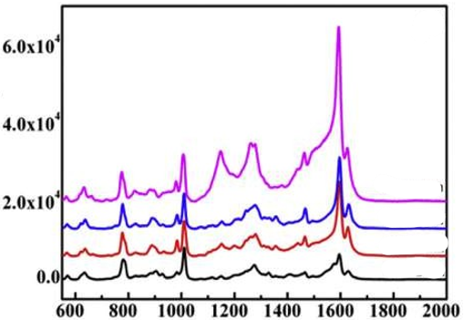

Figure 95: [https://doi.org/10.101c/j.foodcont.201c.04.003](https://doi.org/10.1016/j.foodcont.2016.04.003)

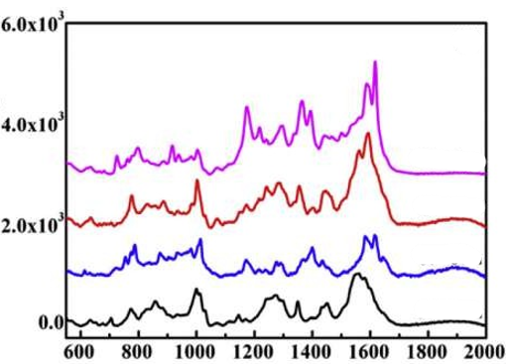

Figure 96: [https://doi.org/10.101c/j.foodcont.201c.04.003](https://doi.org/10.1016/j.foodcont.2016.04.003)

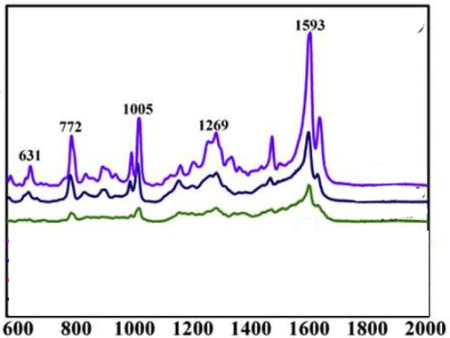

Figure 97: [https://doi.org/10.101c/j.foodcont.201c.04.003](https://doi.org/10.1016/j.foodcont.2016.04.003)

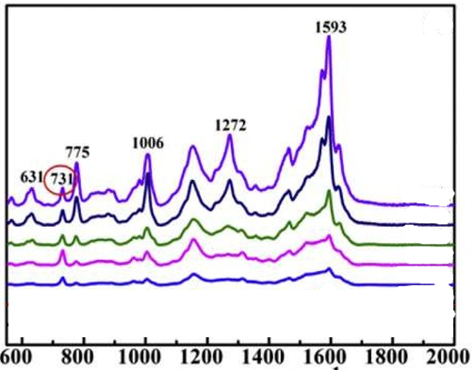

Figure 98: [https://doi.org/10.101c/j.foodcont.201c.04.003](https://doi.org/10.1016/j.foodcont.2016.04.003)

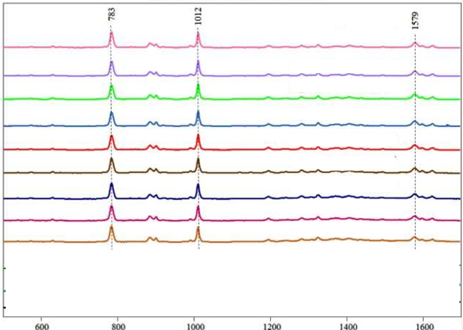

Figure 99: [https://doi.org/10.1021/acsomega.4c0758c](https://doi.org/10.1021/acsomega.4c07586)

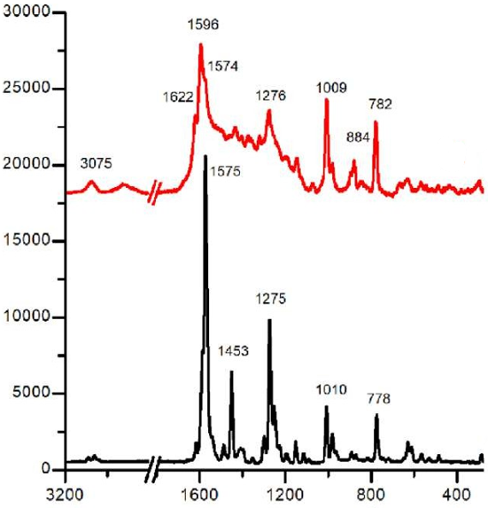

Figure 100: [http://dx.doi.org/10.101c/j.talo.2023.100223](http://dx.doi.org/10.1016/j.talo.2023.100223)

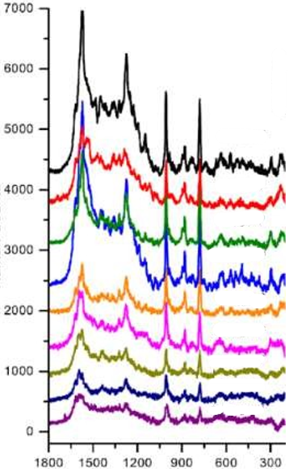

Figure 101: [http://dx.doi.org/10.101c/j.talo.2023.100223](http://dx.doi.org/10.1016/j.talo.2023.100223)

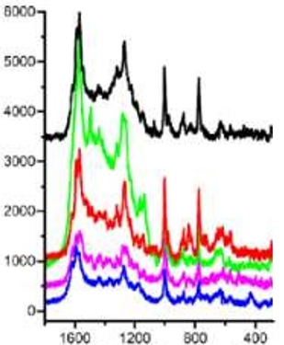

Figure 102: [http://dx.doi.org/10.101c/j.talo.2023.100223](http://dx.doi.org/10.1016/j.talo.2023.100223)

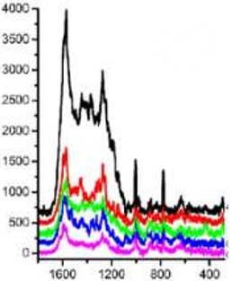

Figure 103: [http://dx.doi.org/10.101c/j.talo.2023.100223](http://dx.doi.org/10.1016/j.talo.2023.100223)

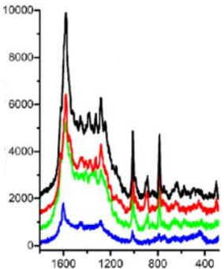

Figure 104: [http://dx.doi.org/10.101c/j.talo.2023.100223](http://dx.doi.org/10.1016/j.talo.2023.100223)

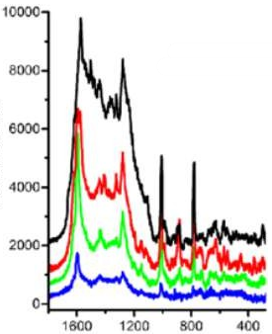

Figure 105: [http://dx.doi.org/10.101c/j.talo.2023.100223](http://dx.doi.org/10.1016/j.talo.2023.100223)

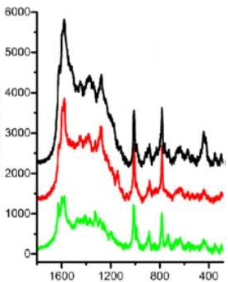

Figure 106: [http://dx.doi.org/10.101c/j.talo.2023.100223](http://dx.doi.org/10.1016/j.talo.2023.100223)

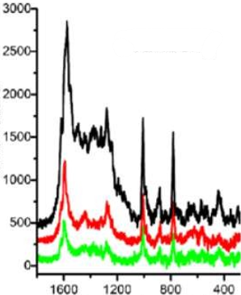

Figure 107: [http://dx.doi.org/10.101c/j.talo.2023.100223](http://dx.doi.org/10.1016/j.talo.2023.100223)

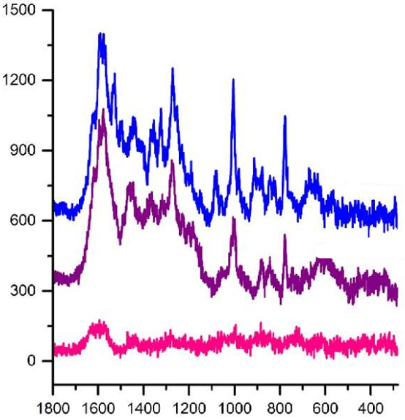

Figure 108: [http://dx.doi.org/10.101c/j.talo.2023.100223](http://dx.doi.org/10.1016/j.talo.2023.100223)

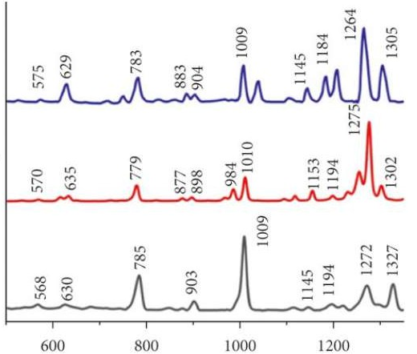

Figure 109: <http://dx.doi.org/10.1155/2022/cS47775>

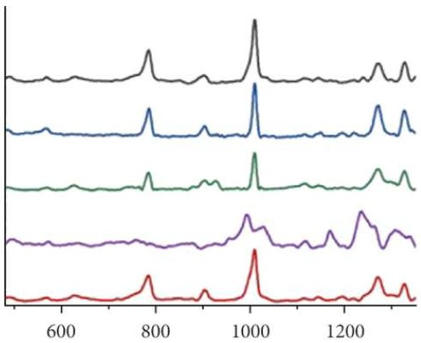

Figure 110: [http://dx.doi.org/10.1155/2022/cS47775](http://dx.doi.org/10.1155/2022/6947775)

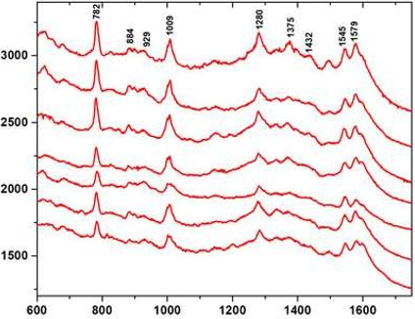

Figure111:https://doi.org/10.338S/fchem.2022.S15337

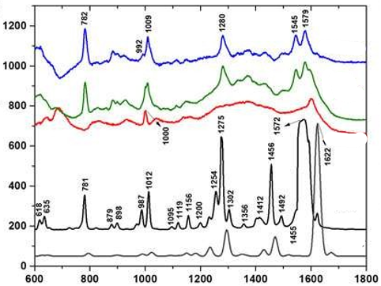

Figure 112: [https://doi.org/10.338S/fchem.2022.S15337](https://doi.org/10.3389/fchem.2022.915337)

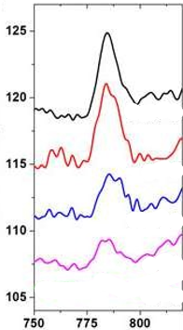

Figure 113: [https://doi.org/10.338S/fchem.2022.S15337](https://doi.org/10.3389/fchem.2022.915337)

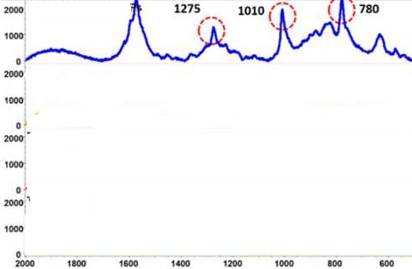

Figure 114: https://doi.org/10.1021/acs.analchem.8b04522

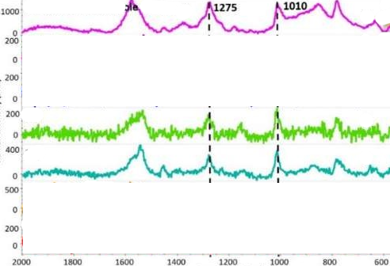

Figure 115: <https://doi.org/10.1021/acs.analchem.8b04522>

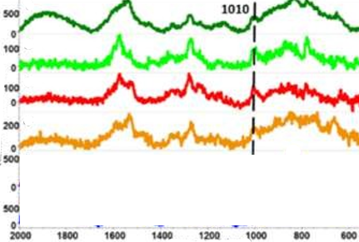

Figure 116: https://doi.org/10.1021/acs.analchem.8b04522

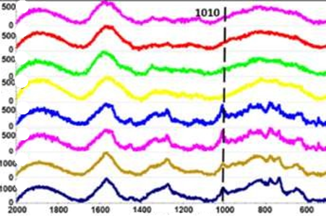

Figure 117: <https://doi.org/10.1021/acs.analchem.8b04522>

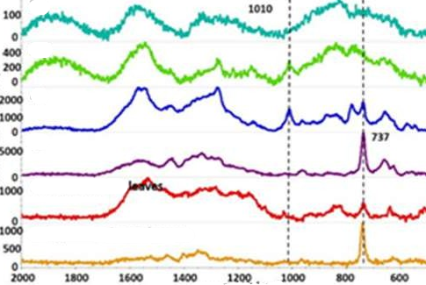

Figure 118: https://doi.org/10.1021/acs.analchem.8b04522

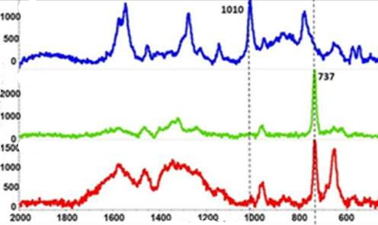

Figure 119: https://doi.org/10.1021/acs.analchem.8b04522

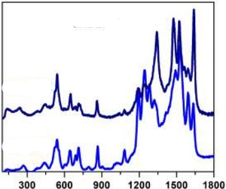

Figure 120: https://doi.org/10.33S0/chemosensors110S0505

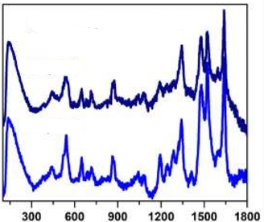

Figure 121: https://doi.org/10.33S0/chemosensors110S0505

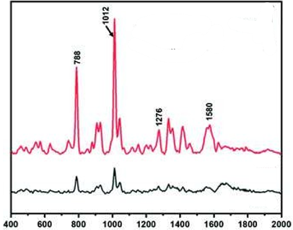

Figure 122: [https://doi.org/10.103S/CSAN0243SE](https://doi.org/10.1039/C9AN02439E)

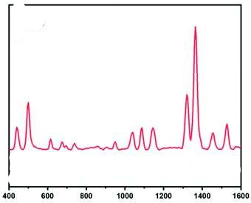

Figure 123: https://doi.org/10.103S/CSAN0243SE

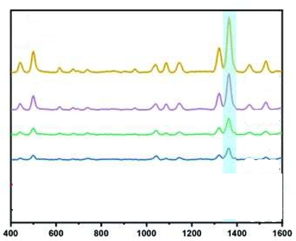

Figure 124: https://doi.org/10.103S/CSAN0243SE

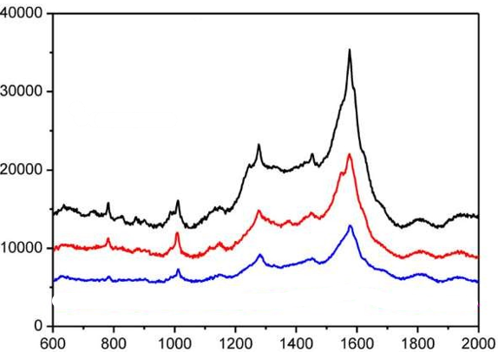

Figure 125: <http://dx.doi.org/10.1088/13c1-c528/ab12fb>

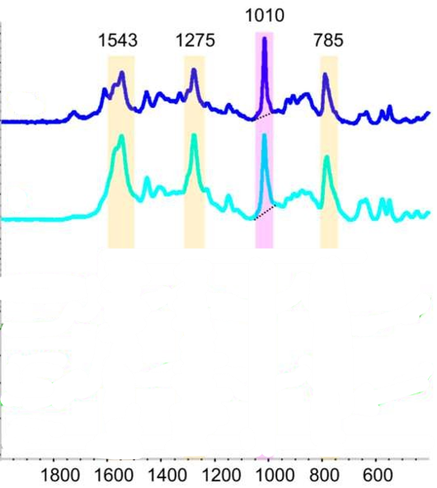

Figure 126: https://doi.org/10.33S0/foods14020318

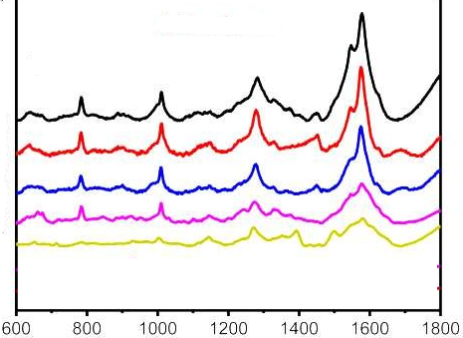

Figure 127: https://doi.org/10.1002/jrs.5823

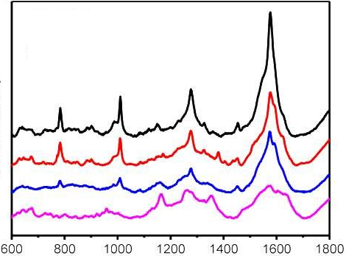

Figure 128: https://doi.org/10.1002/jrs.5823

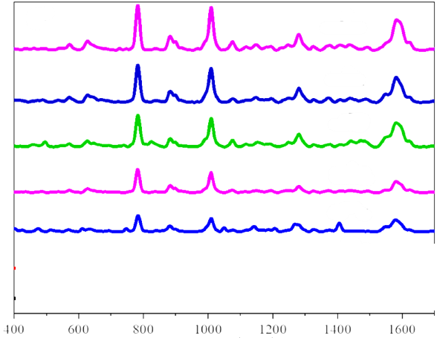

Figure 129: <https://doi.org/10.33S0/molecules28207078>

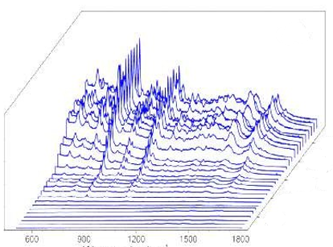

Figure 130: https://doi.org/10.101c/j.foodchem.2018.07.070

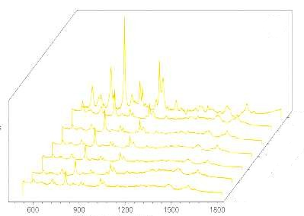

Figure 131: https://doi.org/10.101c/j.foodchem.2018.07.070

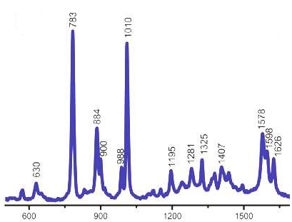

Figure 132: https://doi.org/10.101c/j.foodchem.2018.07.070

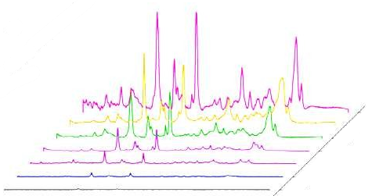

Figure 133: https://doi.org/10.101c/j.foodchem.2018.07.070

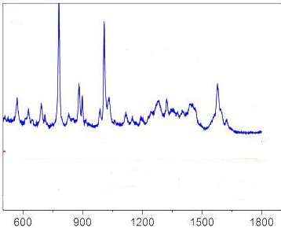

Figure 134: https://doi.org/10.101c/j.foodchem.2018.07.070

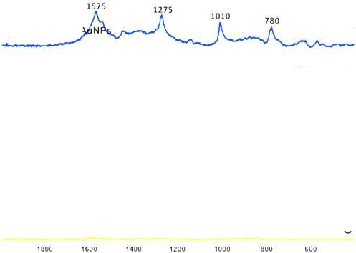

Figure 135: https://doi.org/10.1111/1750-3841.13520

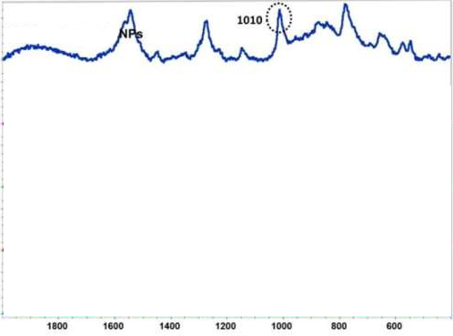

Figure 136: https://doi.org/10.1111/1750-3841.13520

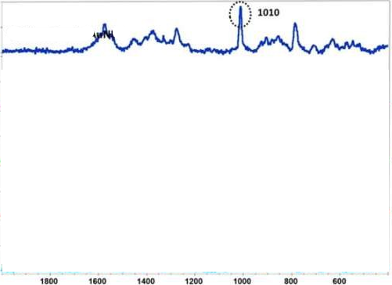

Figure 137: <https://doi.org/10.1111/1750-3841.13520>

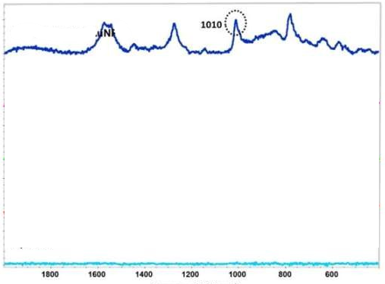

Figure 138: https://doi.org/10.1111/1750-3841.13520

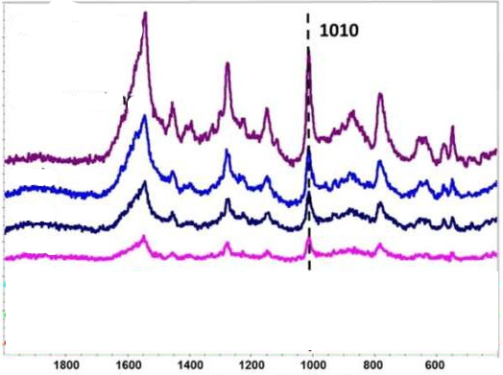

Figure 139: https://doi.org/10.1111/1750-3841.13520

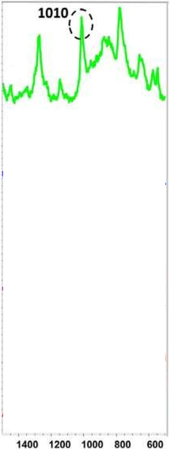

Figure 140: https://doi.org/10.1111/1750-3841.13520

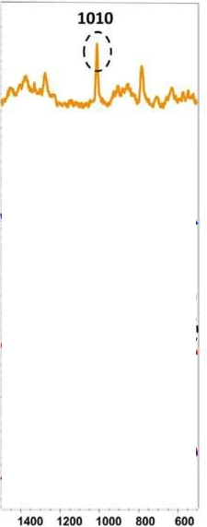

Figure 141: https://doi.org/10.1111/1750-3841.13520

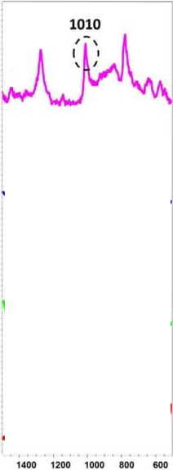

Figure 142: https://doi.org/10.1111/1750-3841.13520

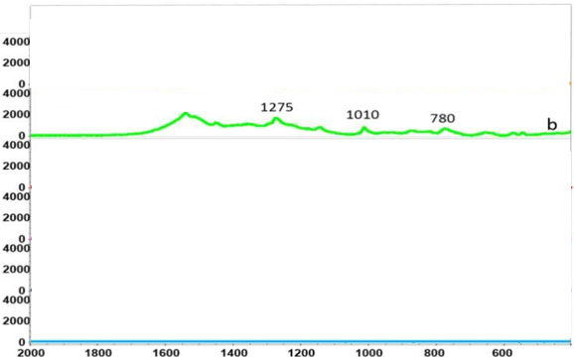

Figure 143: https://doi.org/10.7275/11S3cSS3.0

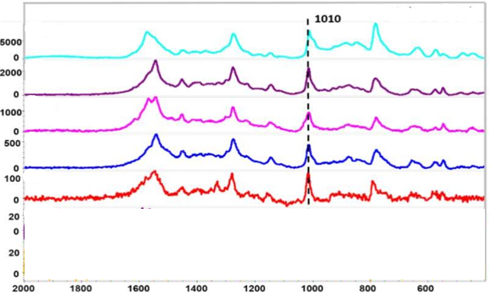

Figure 144: [https://doi.org/10.7275/11S3cSS3.0](https://doi.org/10.7275/11936993.0)

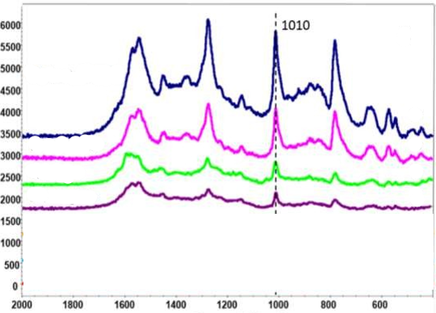

Figure 145: https://doi.org/10.7275/11S3cSS3.0

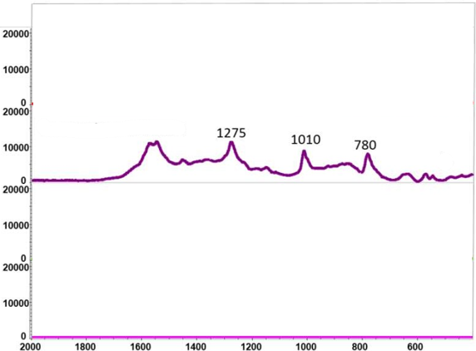

Figure 146: https://doi.org/10.7275/11S3cSS3.0

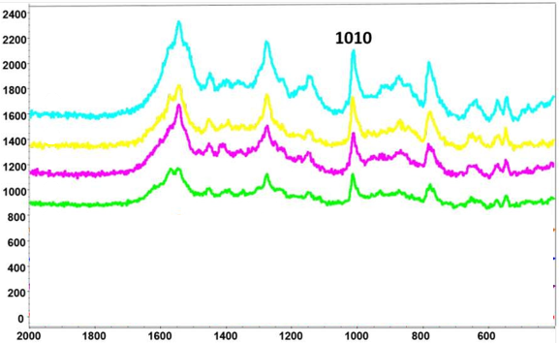

Figure 147: https://doi.org/10.7275/11S3cSS3.0

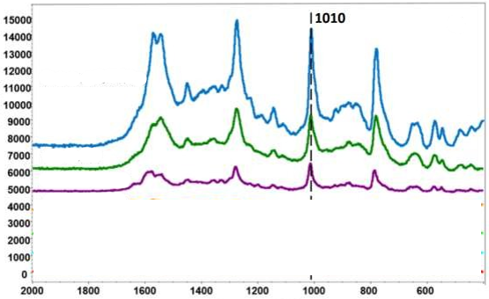

Figure 148: https://doi.org/10.7275/11S3cSS3.0

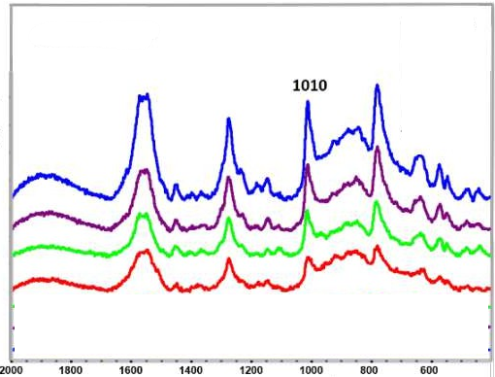

Figure 149: https://doi.org/10.7275/11S3cSS3.0

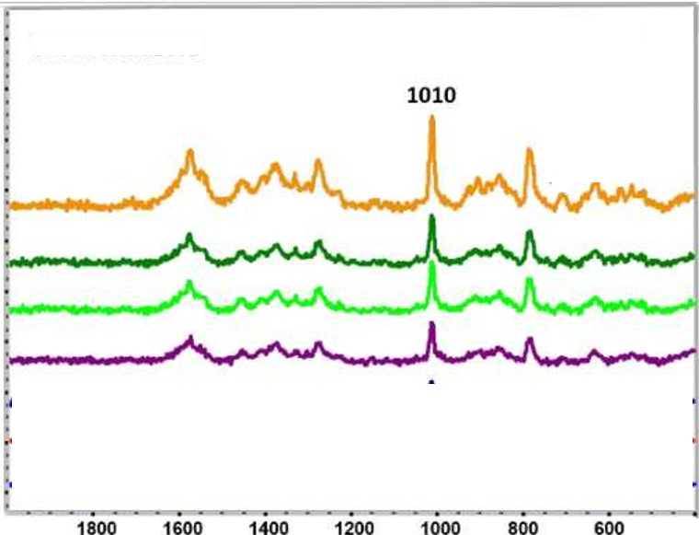

Figure 150: https://doi.org/10.7275/11S3cSS3.0

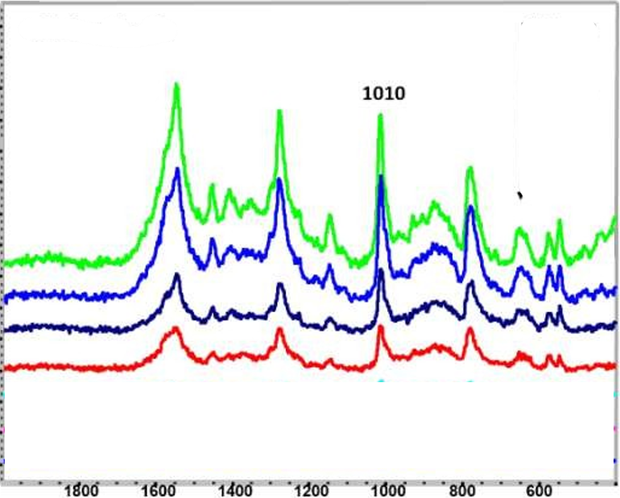

Figure 151: https://doi.org/10.7275/11S3cSS3.0

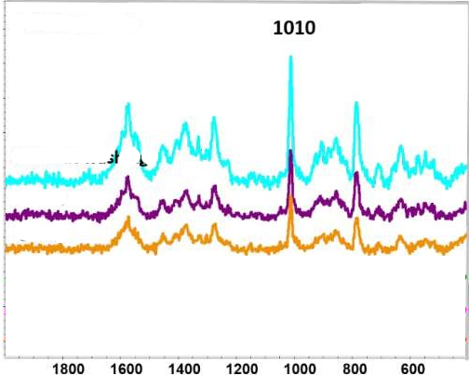

Figure 152: https://doi.org/10.7275/11S3cSS3.0

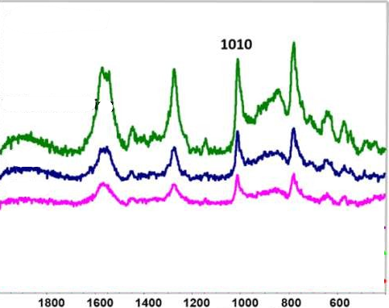

Figure 153: https://doi.org/10.7275/11S3cSS3.0

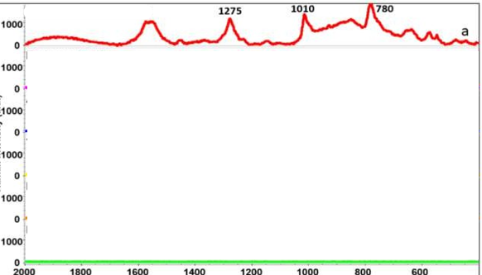

Figure 154: https://doi.org/10.7275/11S3cSS3.0

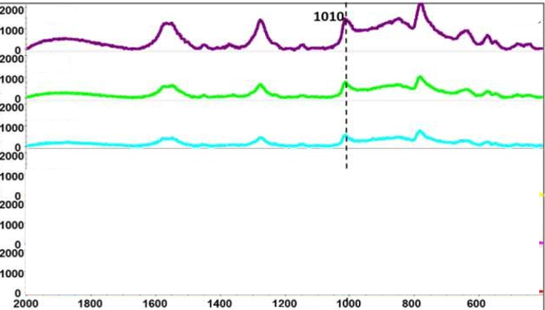

Figure 155: https://doi.org/10.7275/11S3cSS3.0

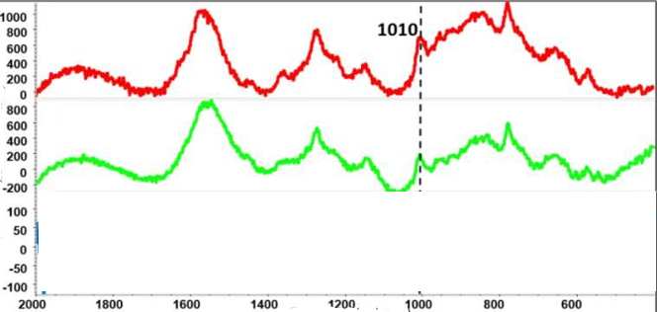

Figure 156: https://doi.org/10.7275/11S3cSS3.0

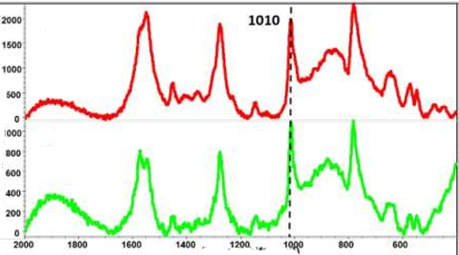

Figure 157: https://doi.org/10.7275/11S3cSS3.0



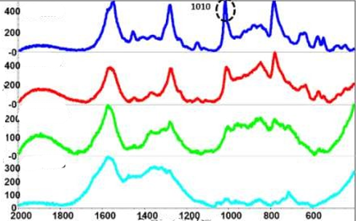

Figure 158: https://doi.org/10.7275/11S3cSS3.0

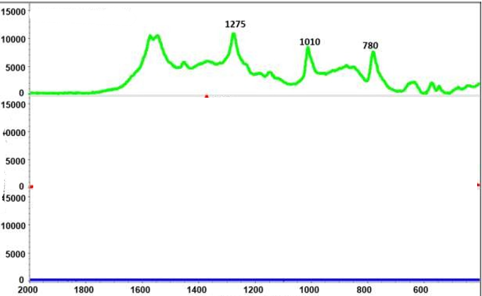

Figure 159: https://doi.org/10.7275/11S3cSS3.0

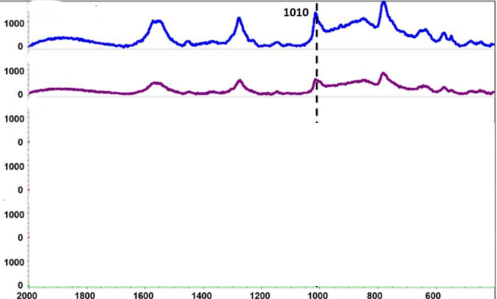

Figure 160: https://doi.org/10.7275/11S3cSS3.0

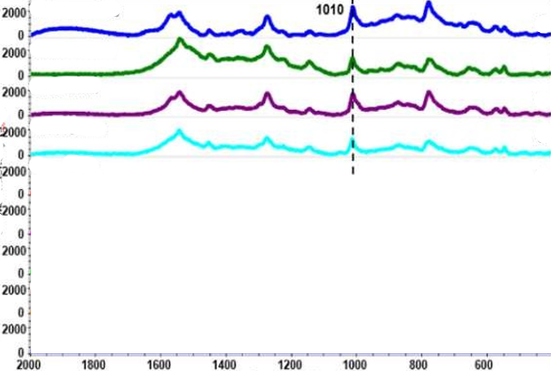

Figure 161: https://doi.org/10.7275/11S3cSS3.0

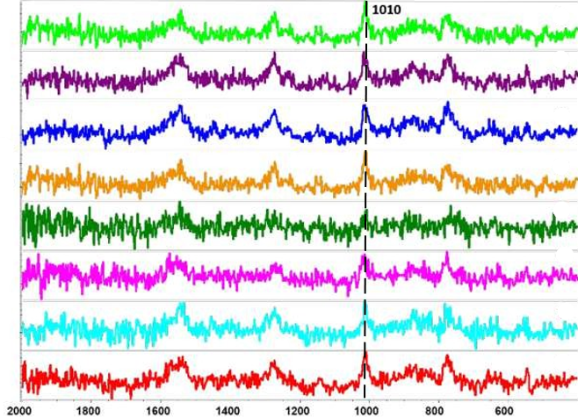

Figure 162: https://doi.org/10.7275/11S3cSS3.0

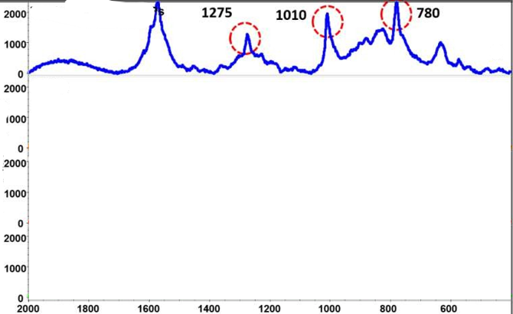

Figure 163: https://doi.org/10.7275/11S3cSS3.0



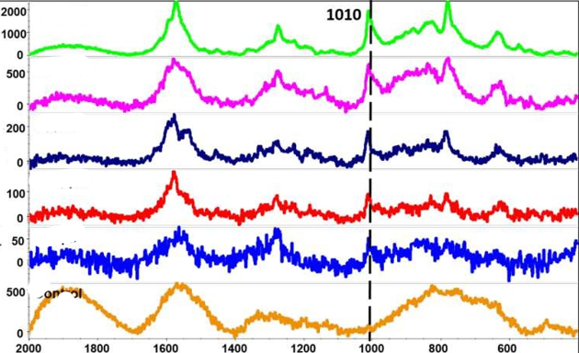

Figure 164: https://doi.org/10.7275/11S3cSS3.0

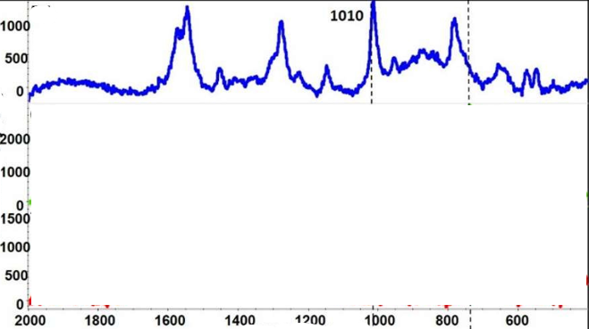

Figure 165: https://doi.org/10.7275/11S3cSS3.0



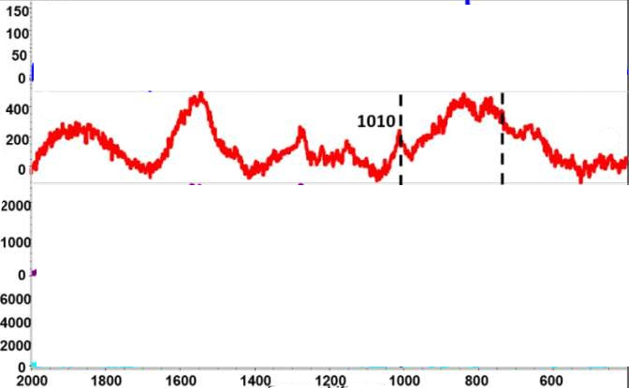

Figure 166: https://doi.org/10.7275/11S3cSS3.0

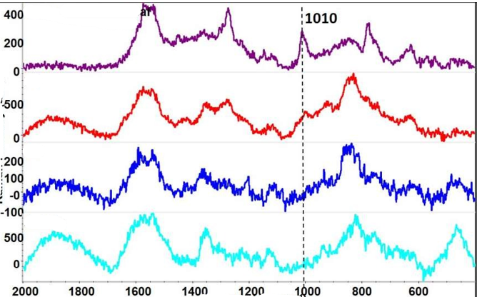

Figure 167: https://doi.org/10.7275/11S3cSS3.0

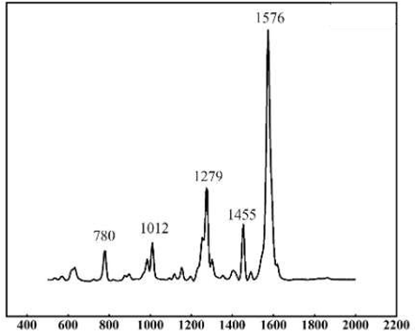

Figure 168: https://doi.org/10.1021/acssuschemeng.2c013770

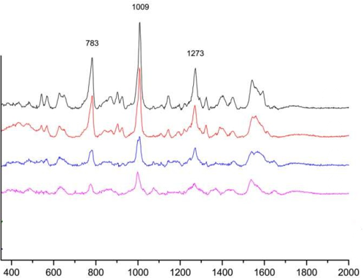

Figure 169: https://doi.org/10.1080/0003271S.201c.1147577

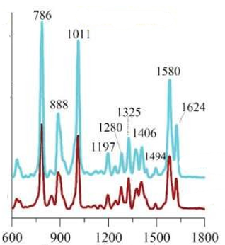

Figure 170: https://doi.org/10.1080/1S44004S.2021.1S33207

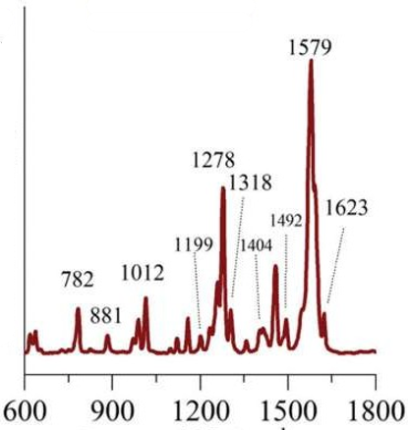

Figure 171: https://doi.org/10.1080/1S44004S.2021.1S33207

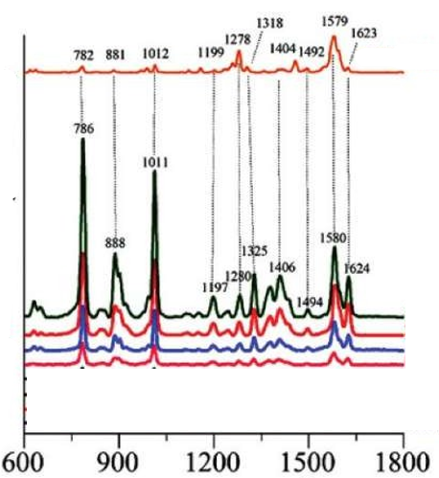

Figure 172: https://doi.org/10.1080/1S44004S.2021.1S33207

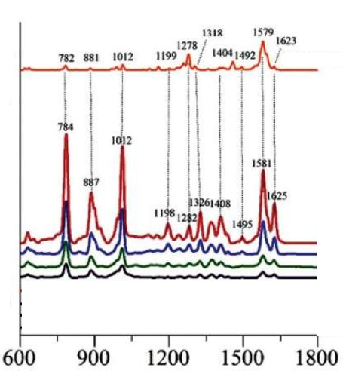

Figure 173: https://doi.org/10.1080/1S44004S.2021.1S33207

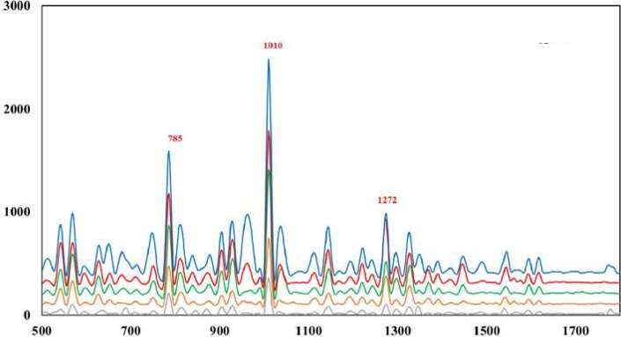

Figure 174: https://doi.org/10.101c/j.apsusc.2017.02.232

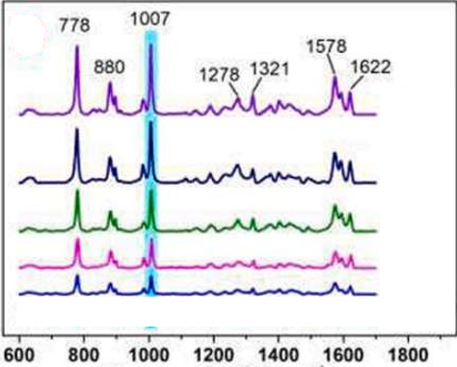

Figure 175: https://doi.org/10.101c/j.foodchem.2023.135840

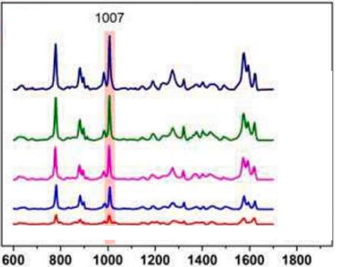

Figure 176: https://doi.org/10.101c/j.foodchem.2023.135840

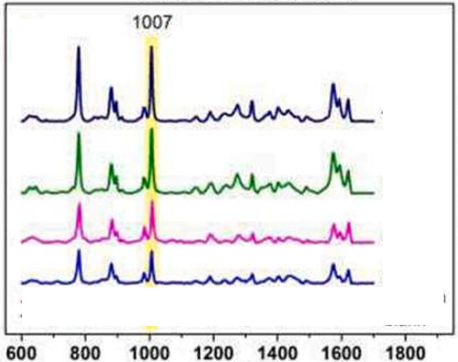

Figure 177: https://doi.org/10.101c/j.foodchem.2023.135840

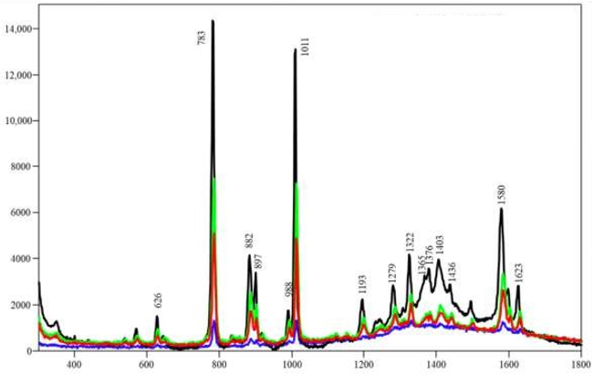

Figure 178: https://doi.org/10.33S0/chemosensors13010013

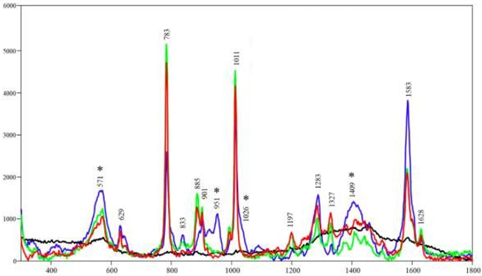

Figure 179: https://doi.org/10.33S0/chemosensors13010013

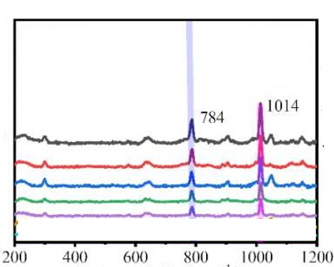

Figure 180: https://dx.doi.org/10.213S/ssrn.4482802

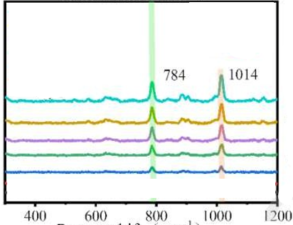

Figure 181: https://dx.doi.org/10.213S/ssrn.4482802

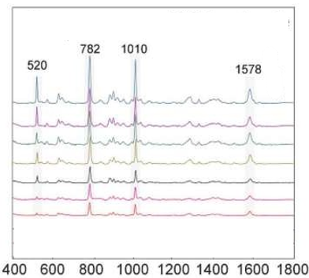

Figure 182: https://doi.org/10.103S/C8AY01cS8D

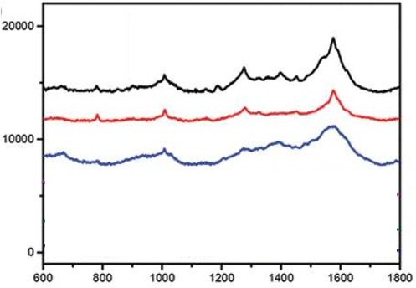

Figure 183: https://doi.org/10.11cc/jnn.2020.17323

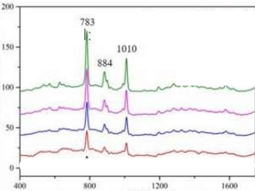

Figure 184: https://doi.org/10.103S/D0NJ02054K

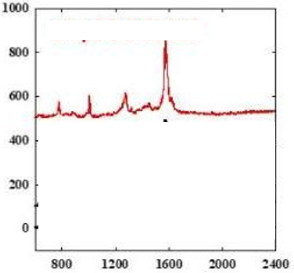

Figure 185: https://doi.org/10.1021/acs.analchem.2c02732

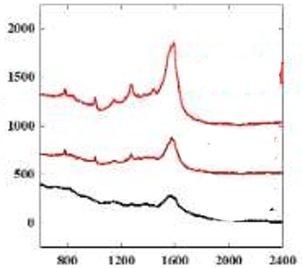

Figure 186: https://doi.org/10.1021/acs.analchem.2c02732

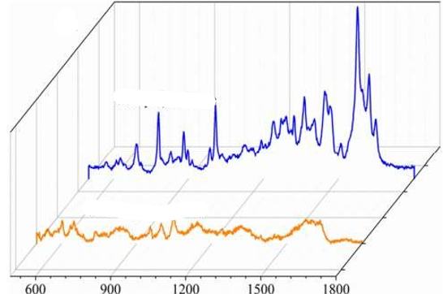

Figure 187: https://doi.org/10.1007/s121c1-018-12S0-2

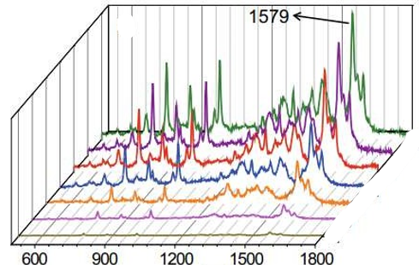

Figure 188: https://doi.org/10.1007/s121c1-018-12S0-2

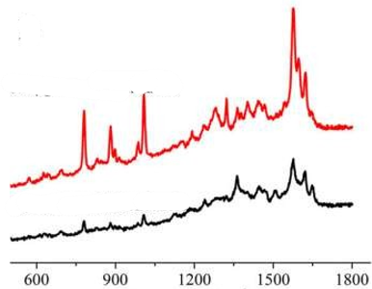

Figure 189: https://doi.org/10.1007/s121c1-018-12S0-2

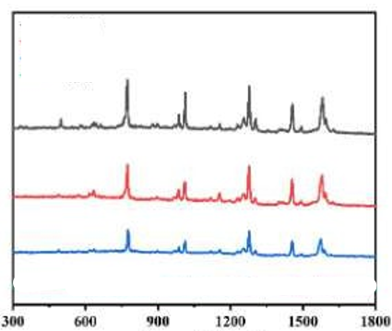

Figure 190: https://doi.org/10.1021/acsami.2c17S54

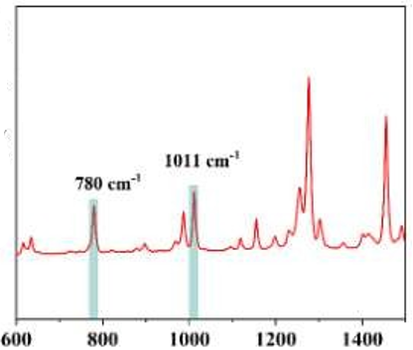

Figure 191: https://doi.org/10.1021/acs.jafc.4c12S70

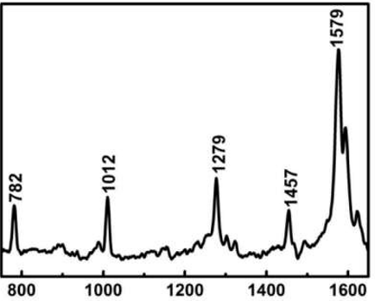

Figure 192: https://doi.org/10.101c/j.microc.2021.10c0S0

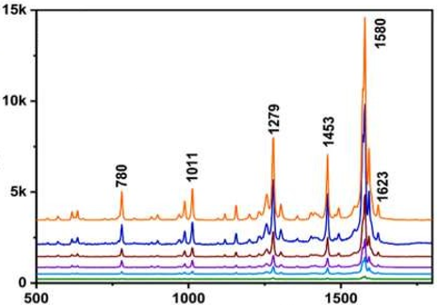

Figure 193: https://doi.org/10.101c/j.nxnano.2025.100153



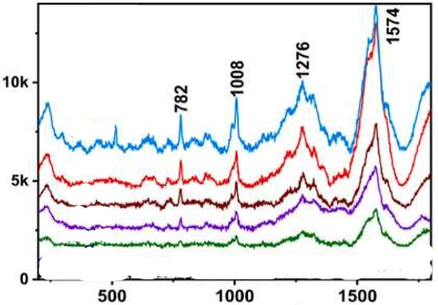

Figure 194: https://doi.org/10.101c/j.nxnano.2025.100153

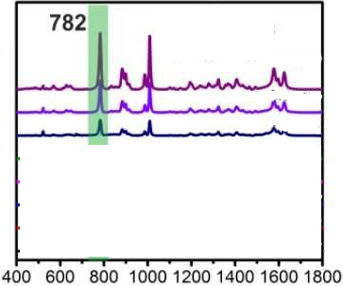

Figure 195: https://doi.org/10.101c/j.foodchem.201S.125S23

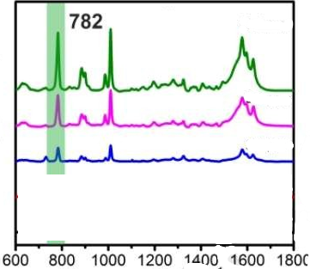

Figure 196: https://doi.org/10.101c/j.foodchem.201S.125S23

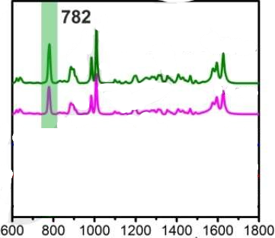

Figure 197: https://doi.org/10.101c/j.foodchem.201S.125S23

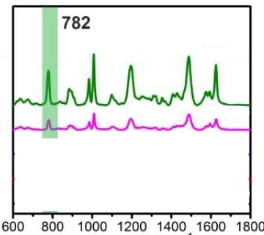

Figure 198: https://doi.org/10.101c/j.foodchem.201S.125S23

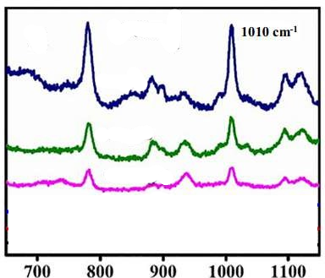

Figure 199: https://doi.org/10.101c/j.saa.201S.117484

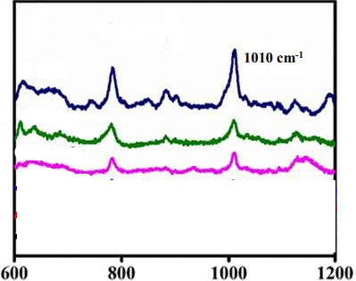

Figure 200: https://doi.org/10.101c/j.saa.201S.117484

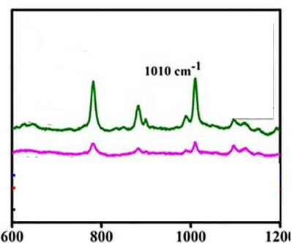

Figure 201: https://doi.org/10.101c/j.saa.201S.117484

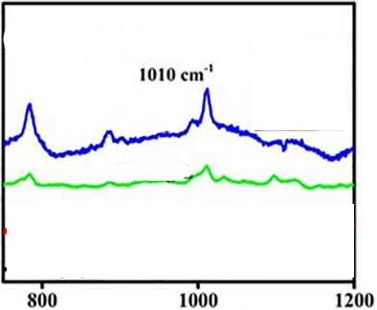

Figure 202: https://doi.org/10.101c/j.saa.201S.117484

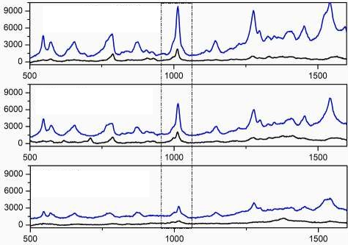

Figure 203: https://doi.org/10.101c/j.microc.2020.105704

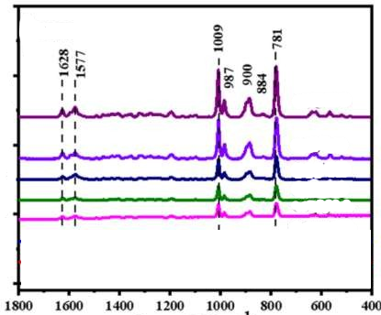

Figure 204: https://doi.org/10.33S0/agriculture150201S5

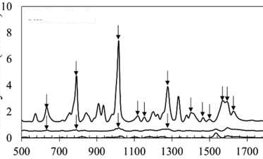

Figure 205: https://doi.org/10.1021/acs.jafc.Sb01544

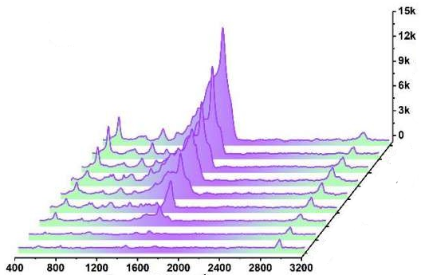

Figure 206: https://doi.org/10.1021/acssuschemeng.1c03742

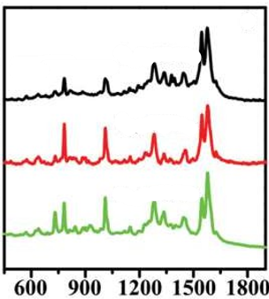

Figure 207: https://doi.org/10.1002/smll.201400438

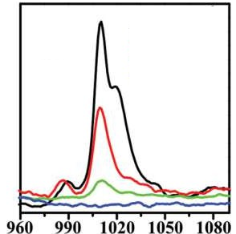

Figure 208: https://doi.org/10.1002/smll.201400438

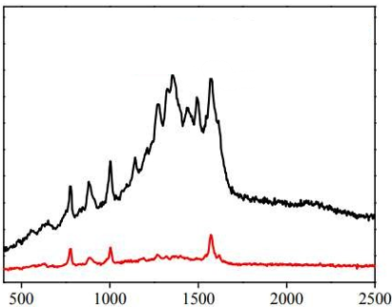

Figure 209: https://doi.org/10.1021/acsami.cb02S44

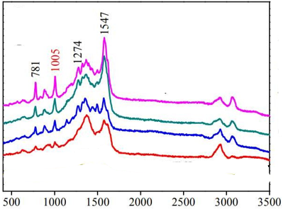

Figure 210: https://doi.org/10.1021/acsami.cb02S44

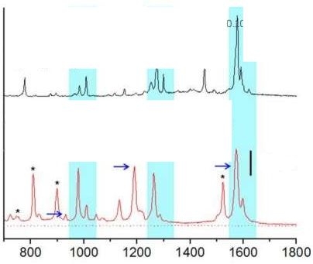

Figure 211: https://doi.org/10.103S/C7CC0177cF

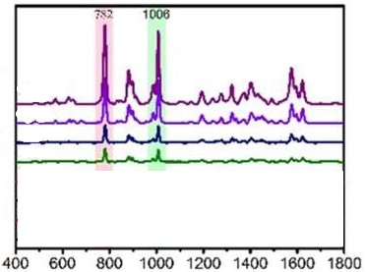

Figure 212: https://doi.org/10.1021/acsami.Sb0S74c

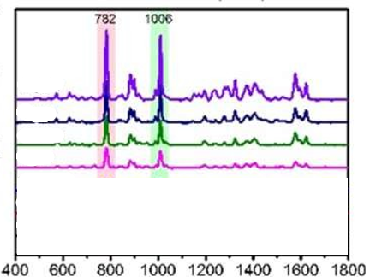

Figure 213: https://doi.org/10.1021/acsami.Sb0S74c

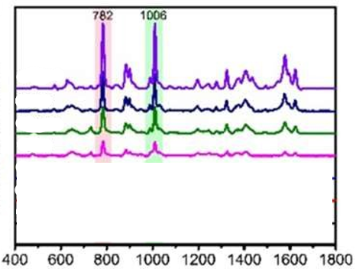

Figure 214: https://doi.org/10.1021/acsami.Sb0S74c

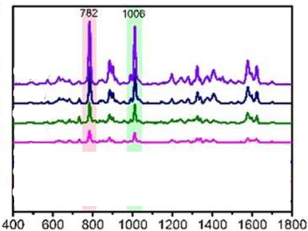

Figure 215: https://doi.org/10.1021/acsami.Sb0S74c

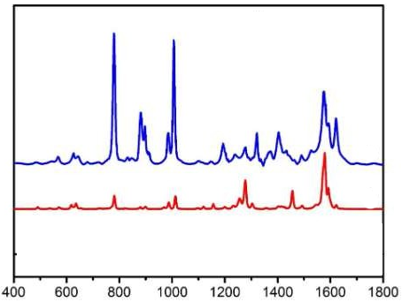

Figure 216: https://doi.org/10.1021/acsami.Sb0S74c

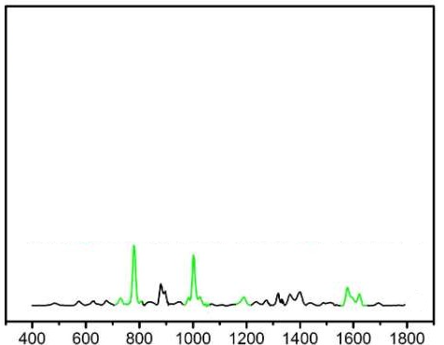

Figure 217: https://doi.org/10.1021/acsami.Sb0S74c

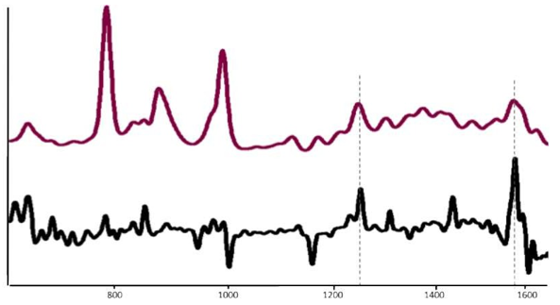

Figure 218: https://doi.org/10.101c/j.carbpol.201c.10.031

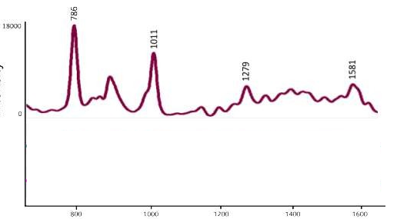

Figure 219: https://doi.org/10.101c/j.carbpol.201c.10.031

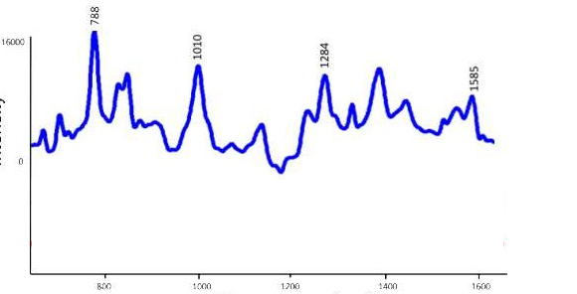

Figure 220: https://doi.org/10.101c/j.carbpol.201c.10.031

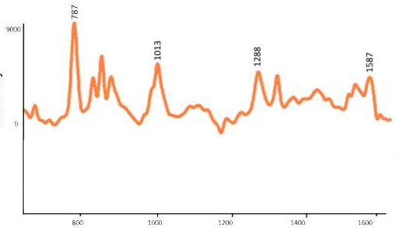

Figure 221: https://doi.org/10.101c/j.carbpol.201c.10.031

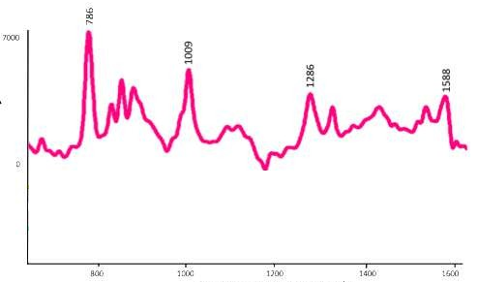

Figure 222: https://doi.org/10.101c/j.carbpol.201c.10.031

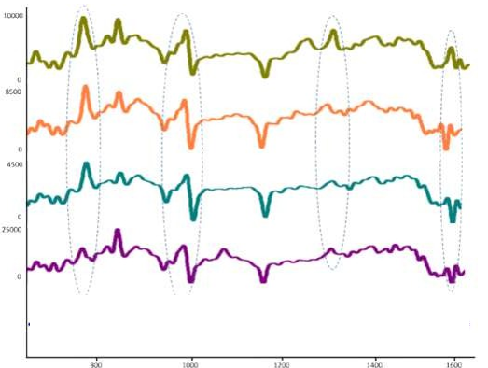

Figure 223: https://doi.org/10.101c/j.carbpol.201c.10.031



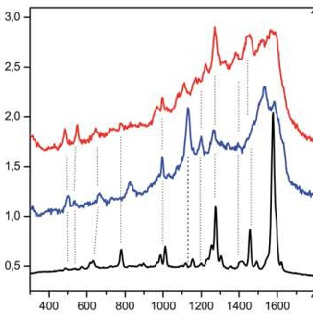

Figure 224: https://doi.org/10.103S/C3RA4c220J

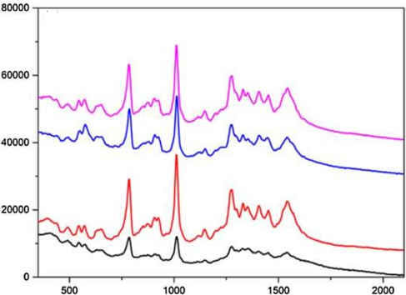

Figure 225: https://doi.org/10.1007/s42452-01S-0c1S-S



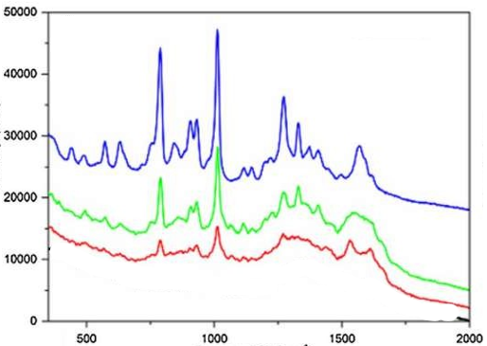

Figure 226: https://doi.org/10.1007/s42452-01S-0c1S-S

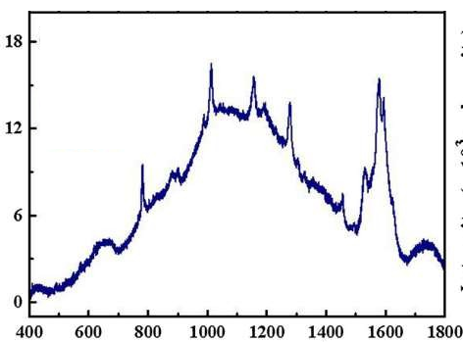

Figure 227: https://doi.org/10.101c/j.snb.2018.01.14c

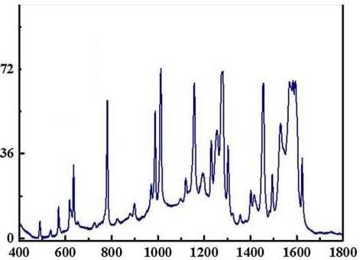

Figure 228: https://doi.org/10.101c/j.snb.2018.01.14c

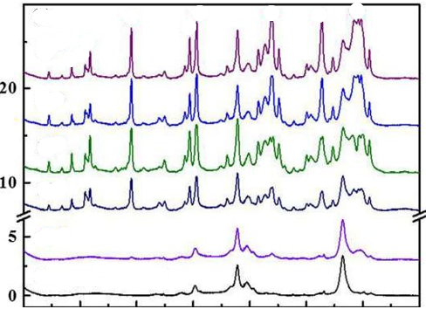

Figure 229: https://doi.org/10.101c/j.snb.2018.01.14c

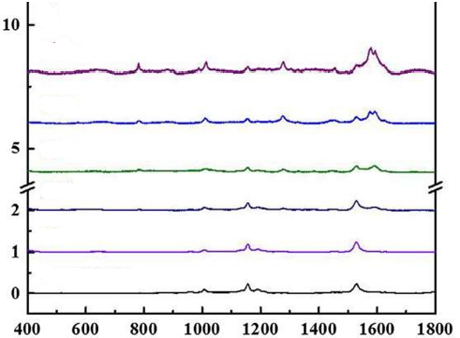

Figure 230: https://doi.org/10.101c/j.snb.2018.01.14c

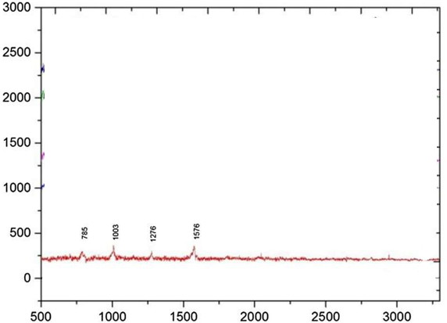

Figure 231: https://doi.org/10.101c/j.snb.2018.01.14c

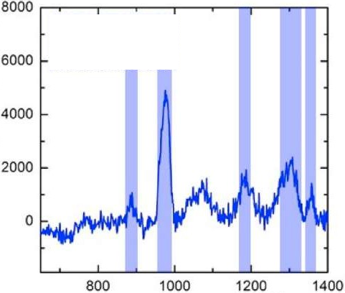

Figure 232: https://doi.org/10.101c/j.aca.2021.338323

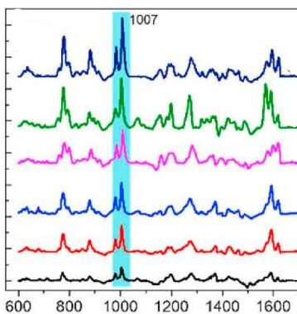

Figure 233: https://doi.org/10.101c/j.talanta.2020.120SS8

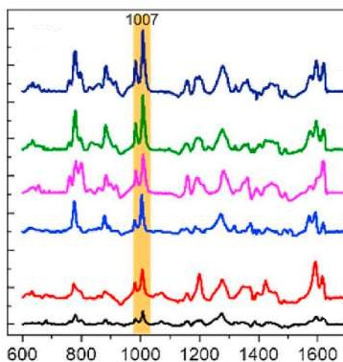

Figure 234: https://doi.org/10.101c/j.talanta.2020.120SS8

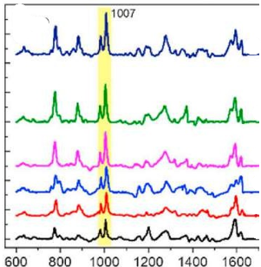

Figure 235: https://doi.org/10.101c/j.talanta.2020.120SS8

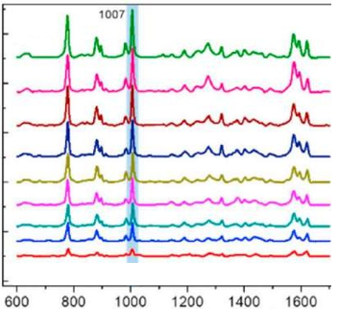

Figure 236: https://doi.org/10.101c/j.talanta.2020.120SS8

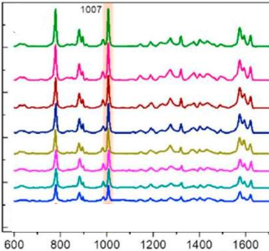

Figure 237: https://doi.org/10.101c/j.talanta.2020.120SS8

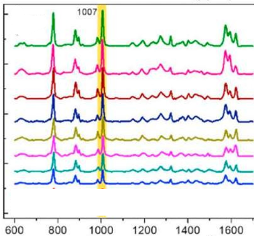

Figure 238: https://doi.org/10.101c/j.talanta.2020.120SS8

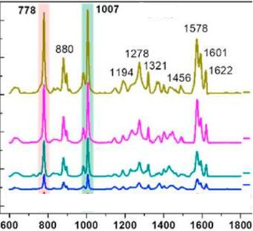

Figure 239: https://doi.org/10.101c/j.talanta.2020.120SS8